**TO CREATE AN S3 BUCKET IN AWS**

Storage 🡪 s3 🡪 create s3 bucket 🡪 general purpose 🡪 name 🡪 create bucket

1. Sign in to the AWS Management Console 🡪 **Navigate** to the **S3** service.

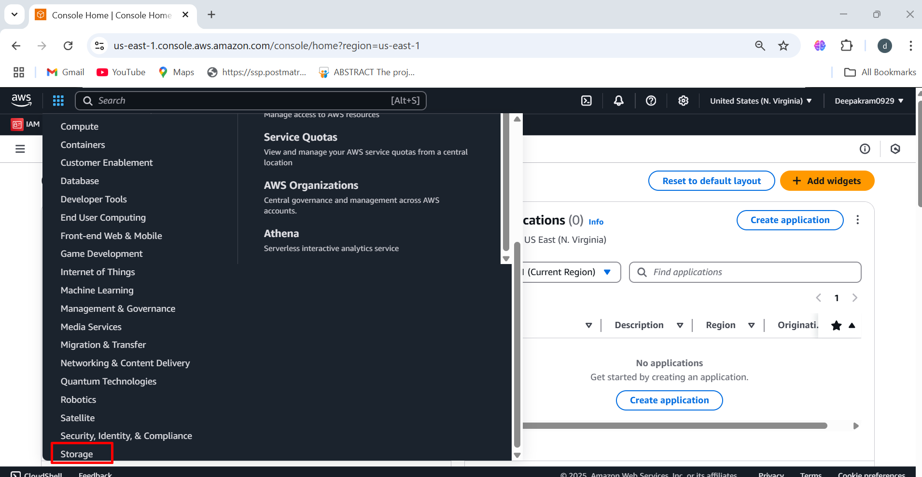

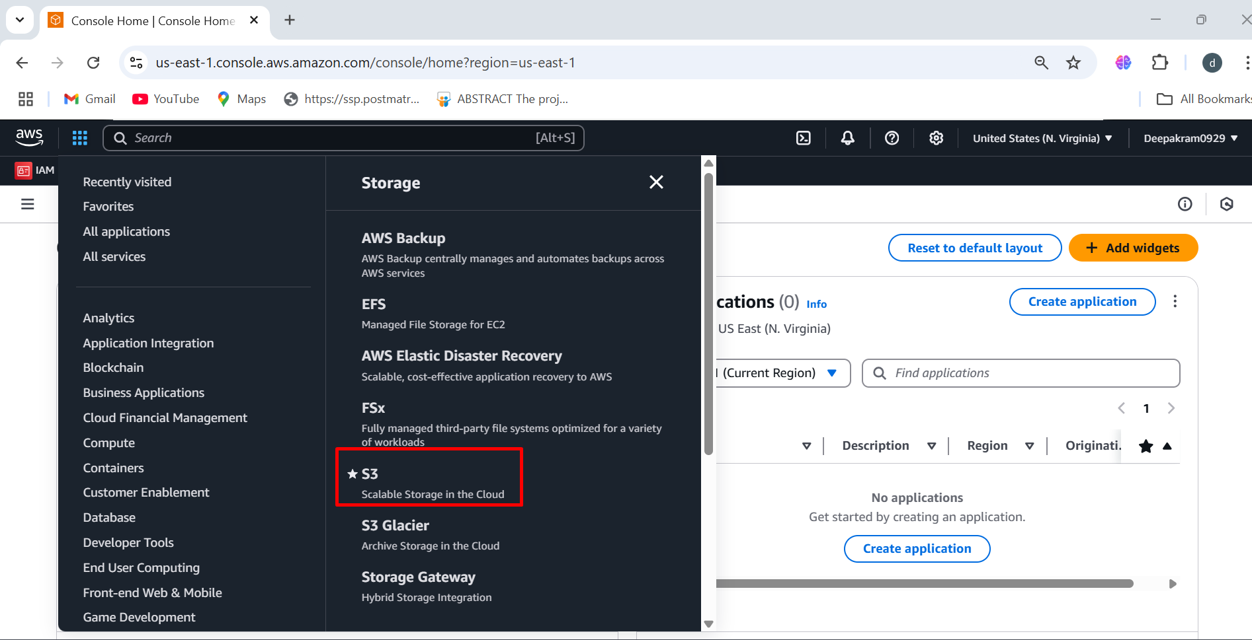

1. Click **Create bucket** 🡪 **General-Purpose**

A **general-purpose S3 bucket** is typically used for storing files, images, backups, logs, or application data. It uses the **S3 Standard** storage class by default, providing high durability, availability, and low latency.

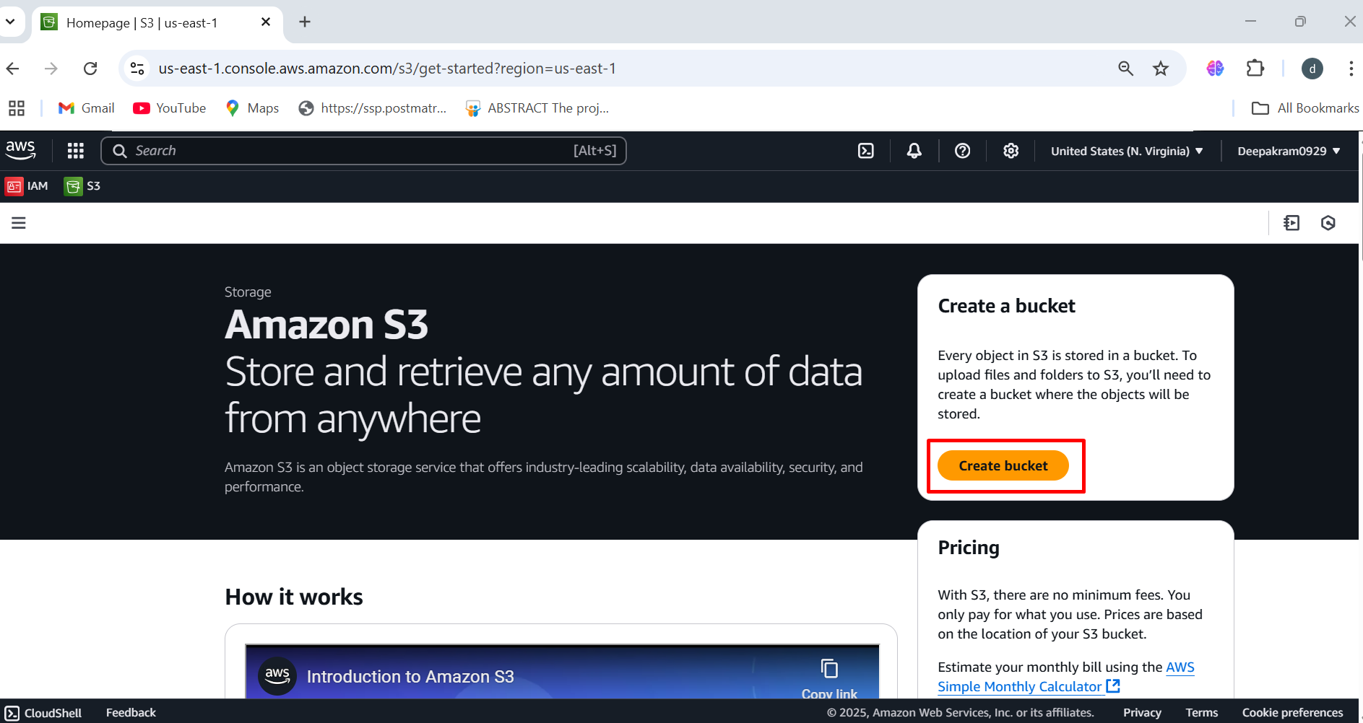

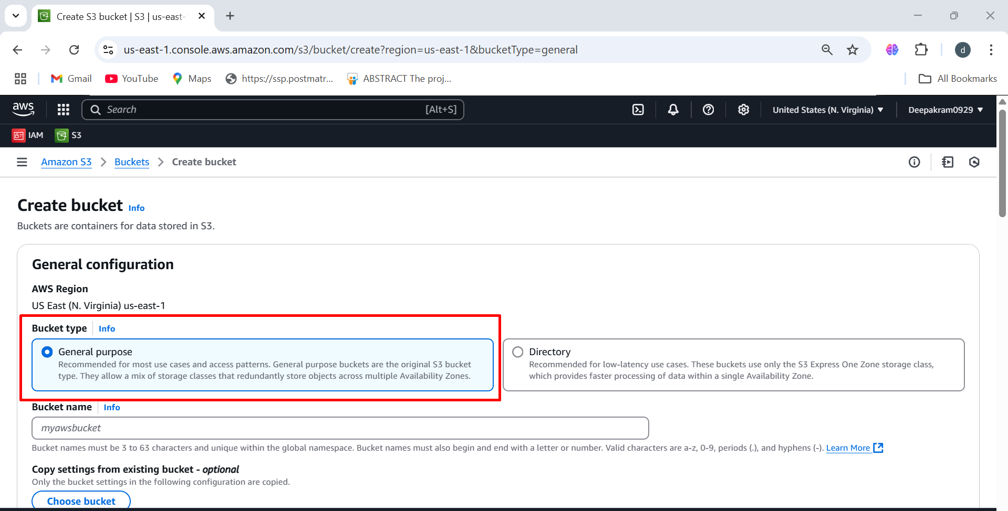

1. Enter a **unique bucket name**

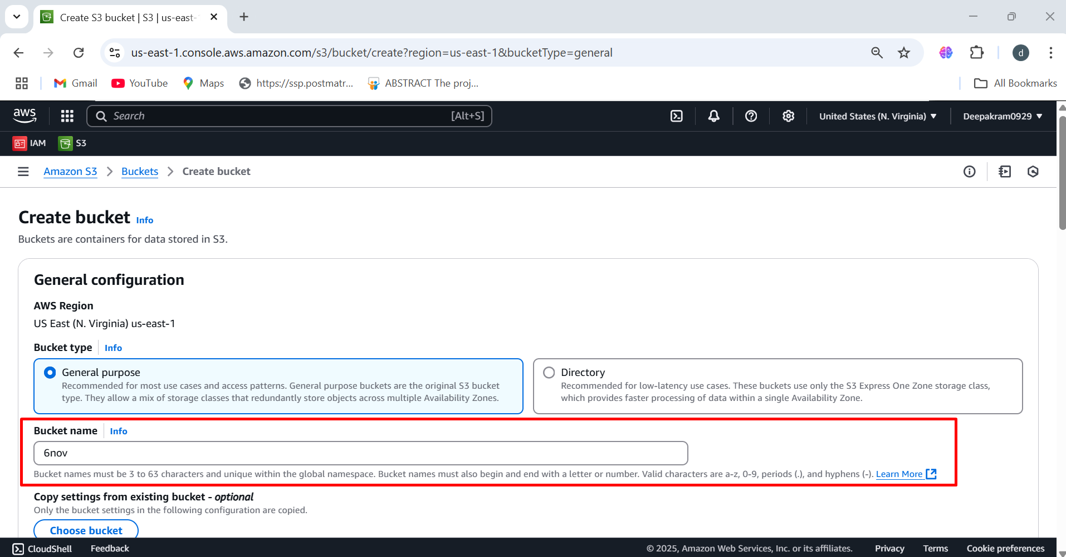

1. Click on create button

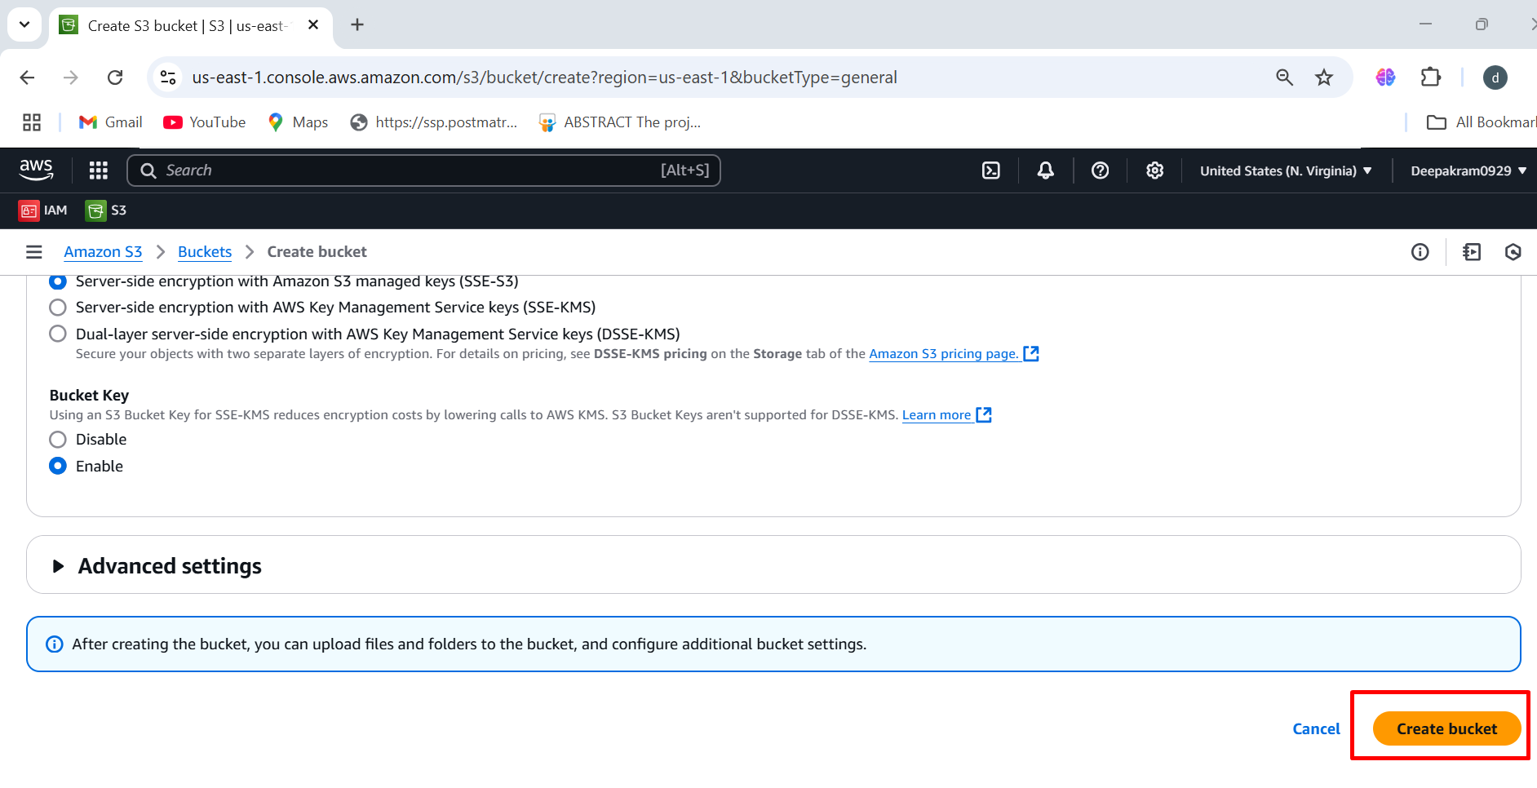

1. **General Purpose S3 Bucket** named **"6nov"** in the **us-east-1 (N. Virginia) region**.

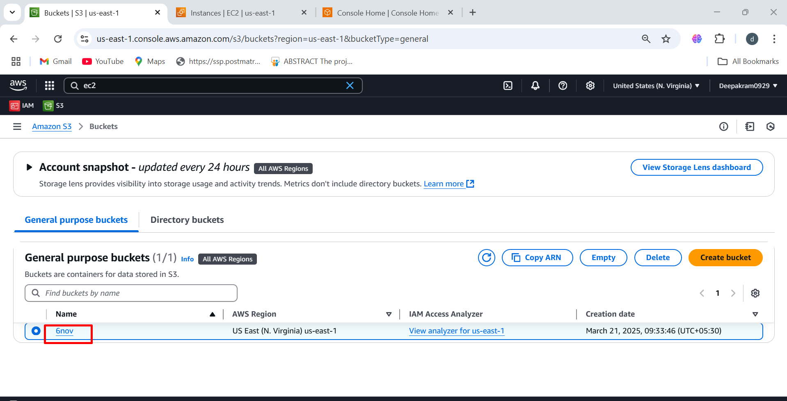

1. No Objects Present, The bucket is empty (no files uploaded yet) 🡪 Clicking **"Upload"** allows you to add files or folders to the S3 bucket.

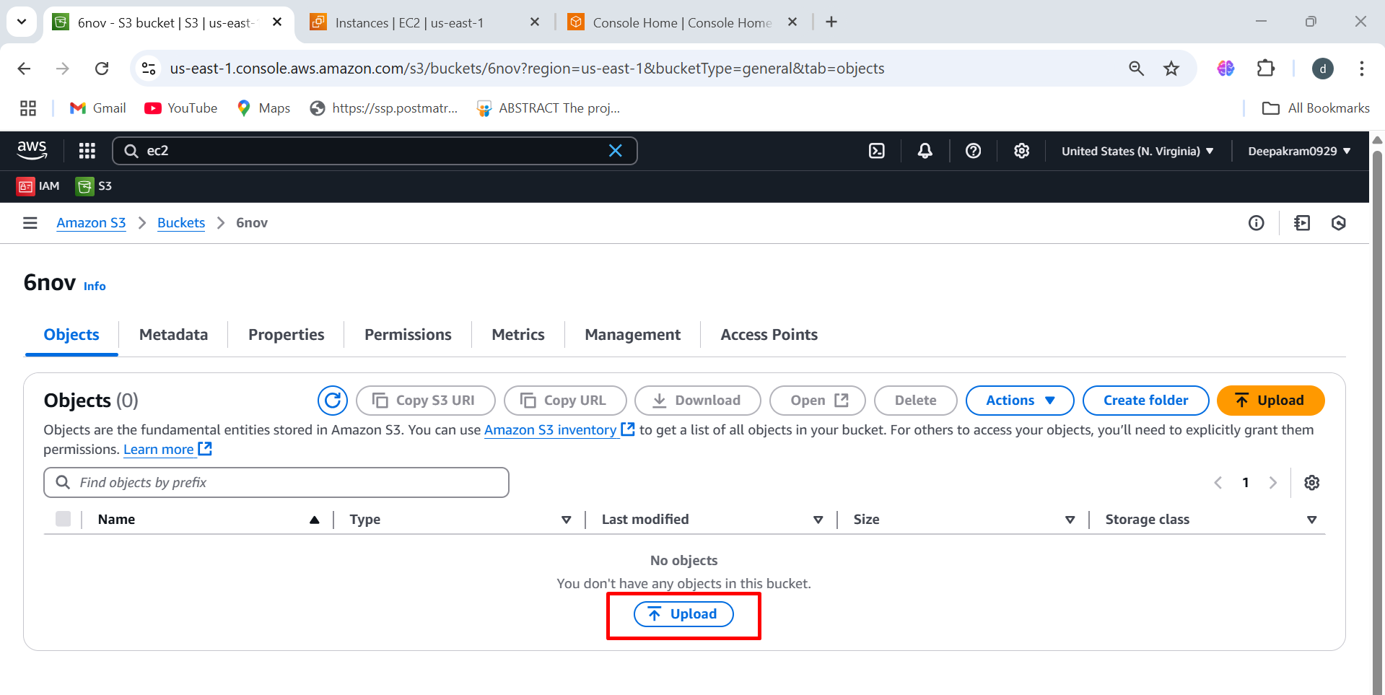

1. You can **drag and drop** files/folders into the upload area 🡪 Alternatively, use the **"Add files"** or **"Add folder"** buttons to select items manually

**“Add files"** → Upload individual files **"Add folder"** → Upload an entire folder (keeps directory structure).

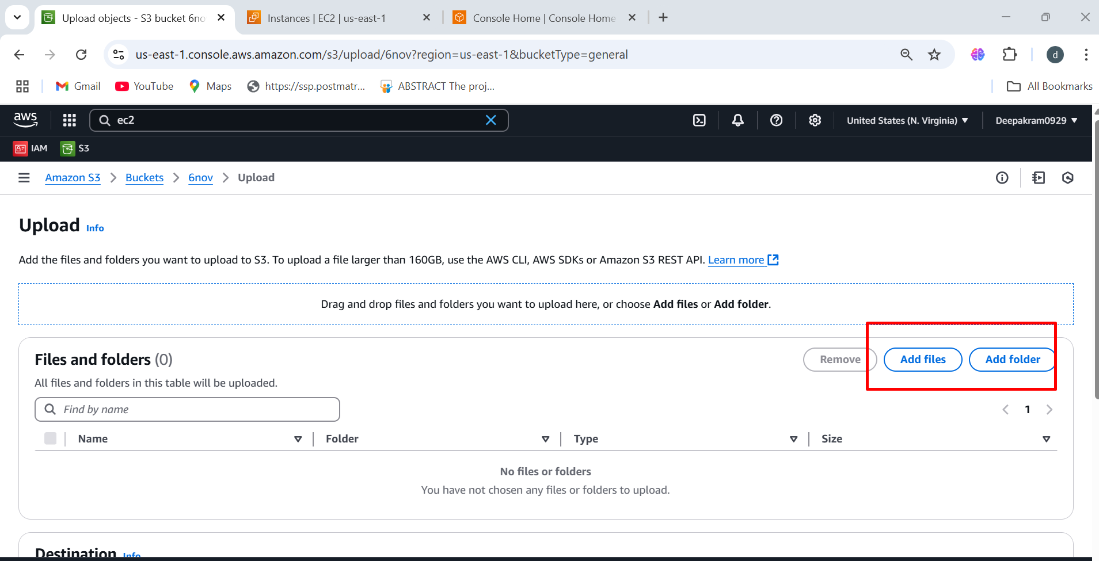

1. Upload file from your local machine

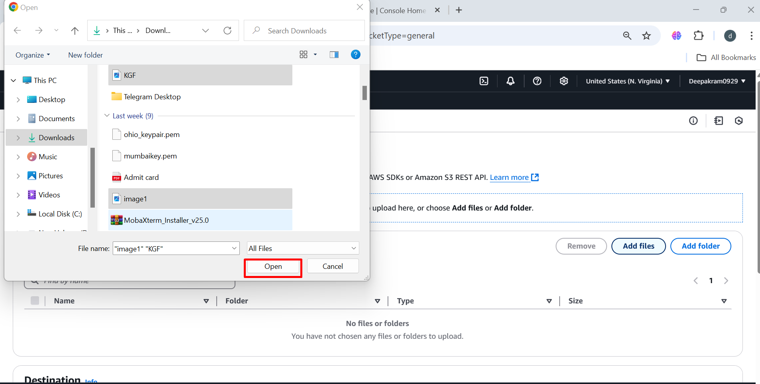

1. Two images are Added to the bucket 🡪 After confirming file selection, click the **"Upload"** button

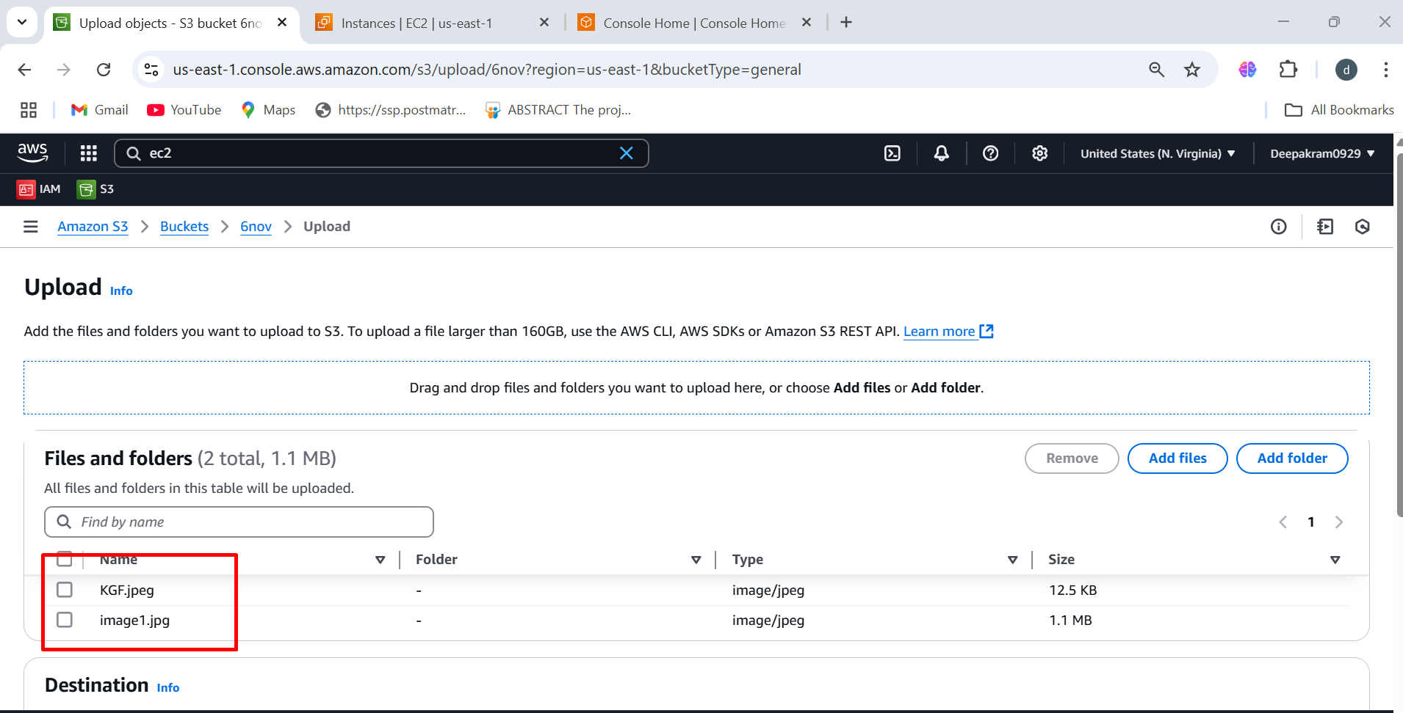

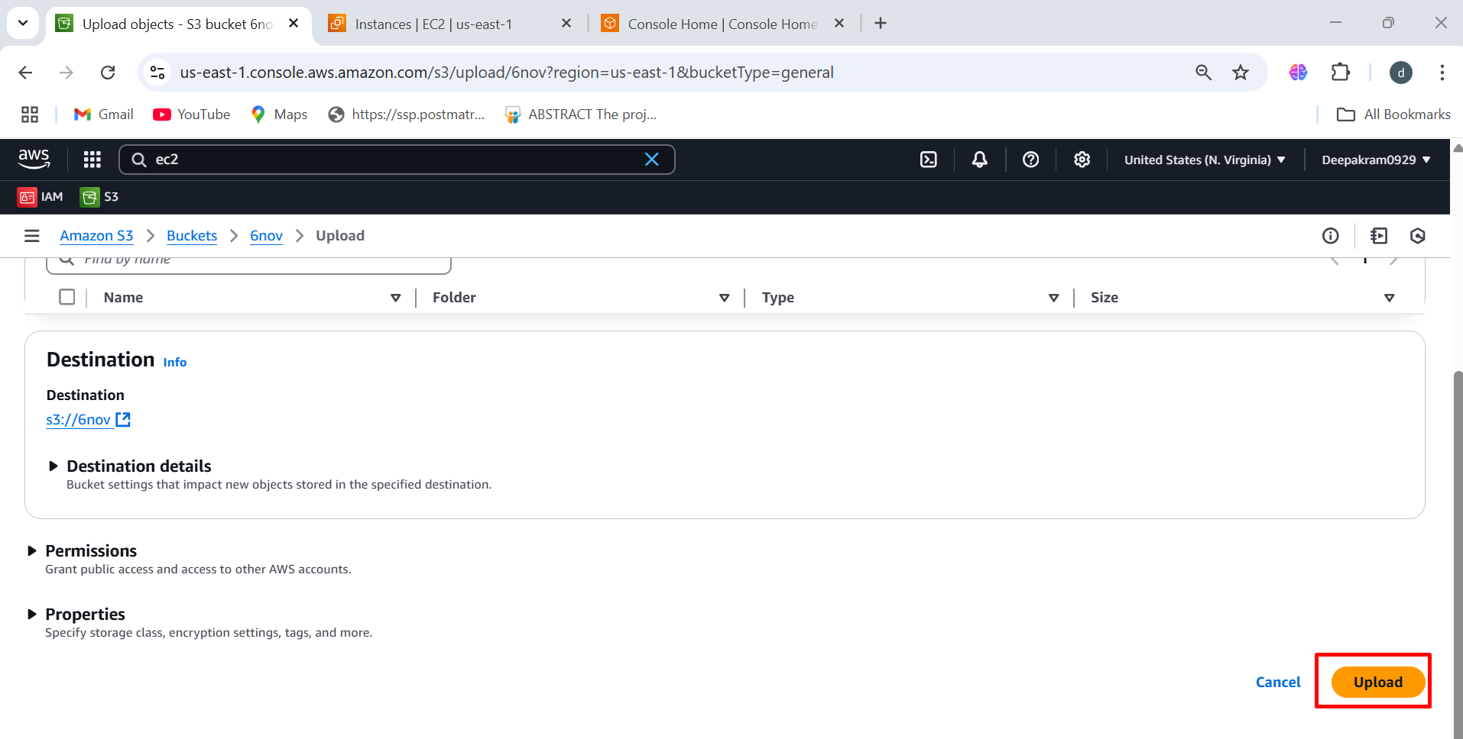

1. **AWS S3 Upload Progress Page**, where two image files are being uploaded to the **"6nov"** bucket.

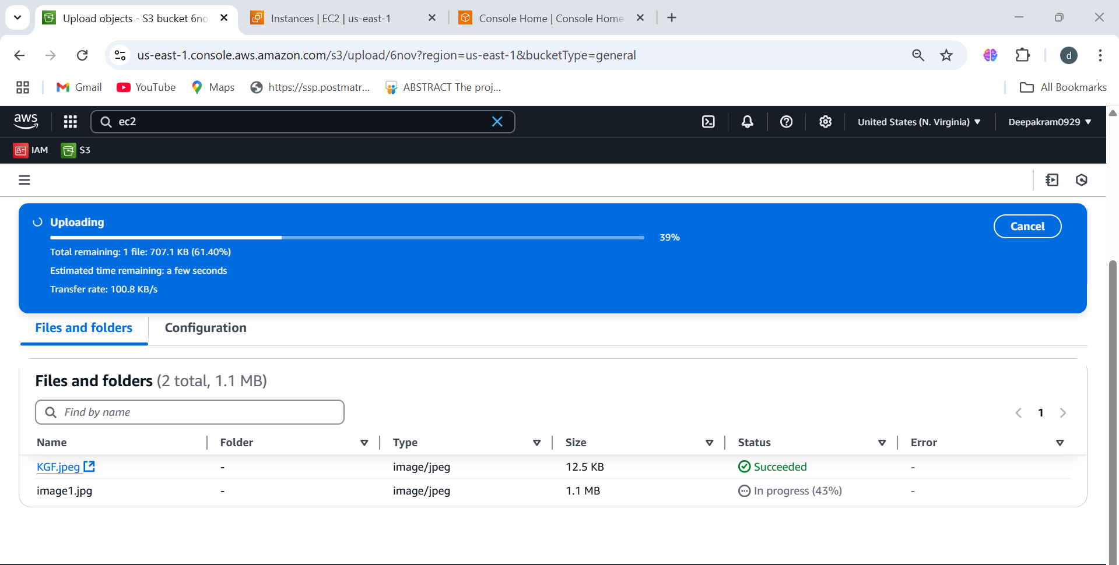

1. confirms that the **file upload to the S3 bucket "6nov" was successful**.

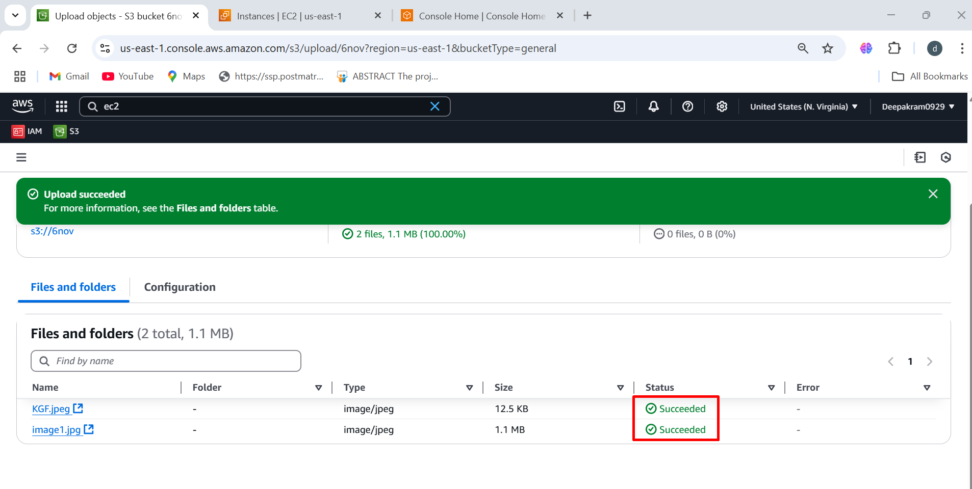

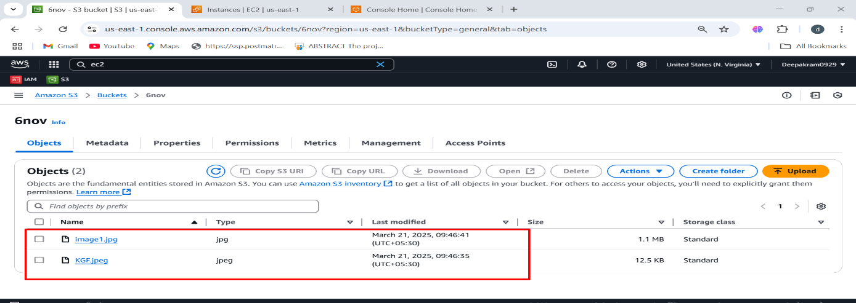

**To Launch EC2 Instance**

Compute 🡪 EC2 🡪 Instance 🡪 Launch Instance 🡪 Name 🡪AMS’S

**[ Amazon Linux 2023 AMI ]** 🡪 X86 (Architecture) 🡪 Instance **type:** t2.micro

(1 CPU & 1GB RAM) 🡪 Key pair 🡪 Name 🡪 **RSA**  🡪  **.Pem (open ssh )** 🡪 Save

Select existing security group 🡪 ssh -security group 🡪 configure storage

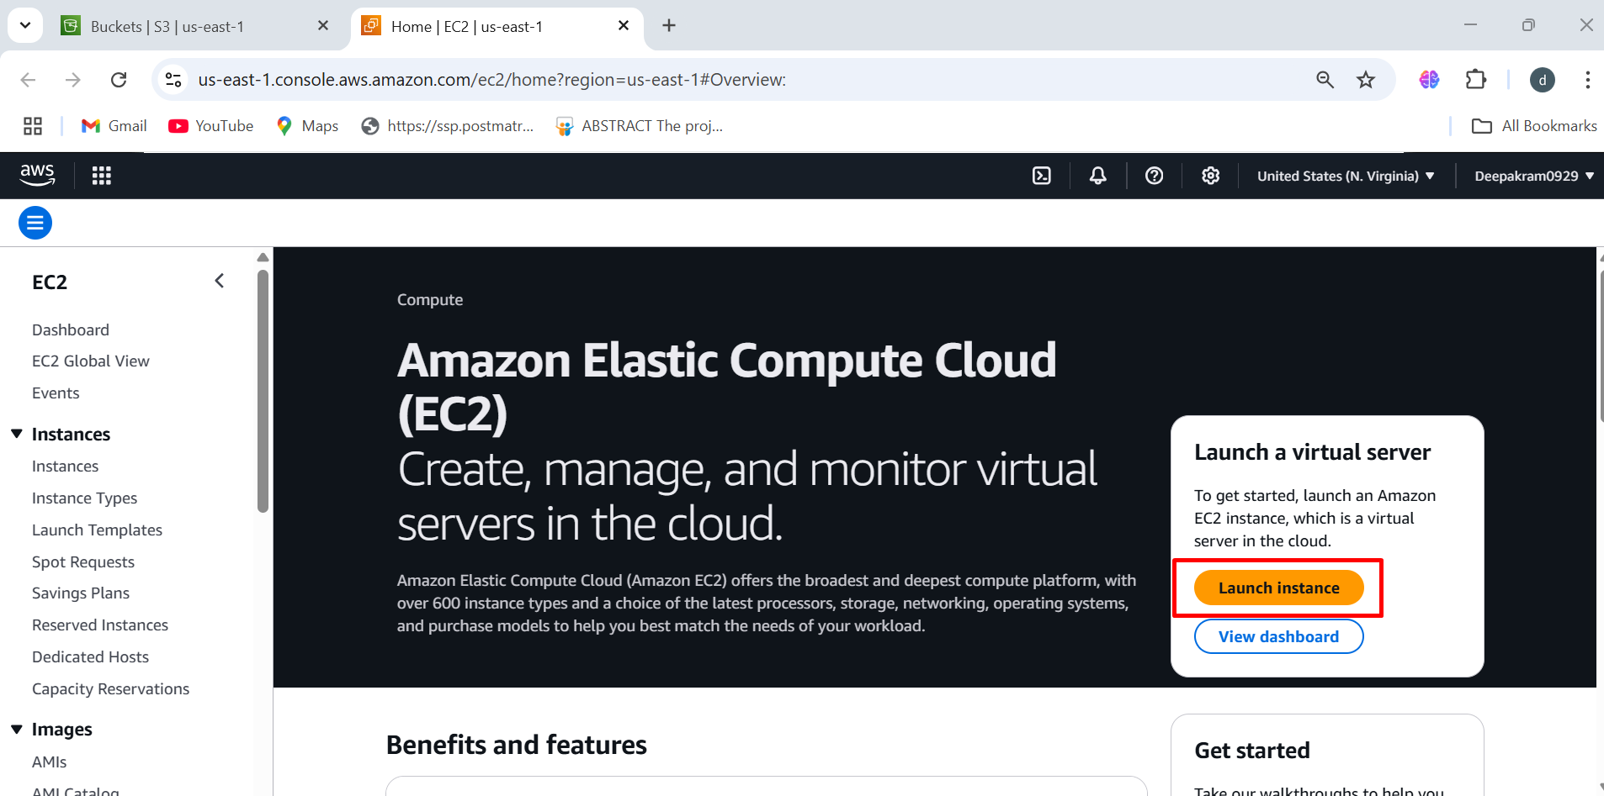

1. Provide the name for instance

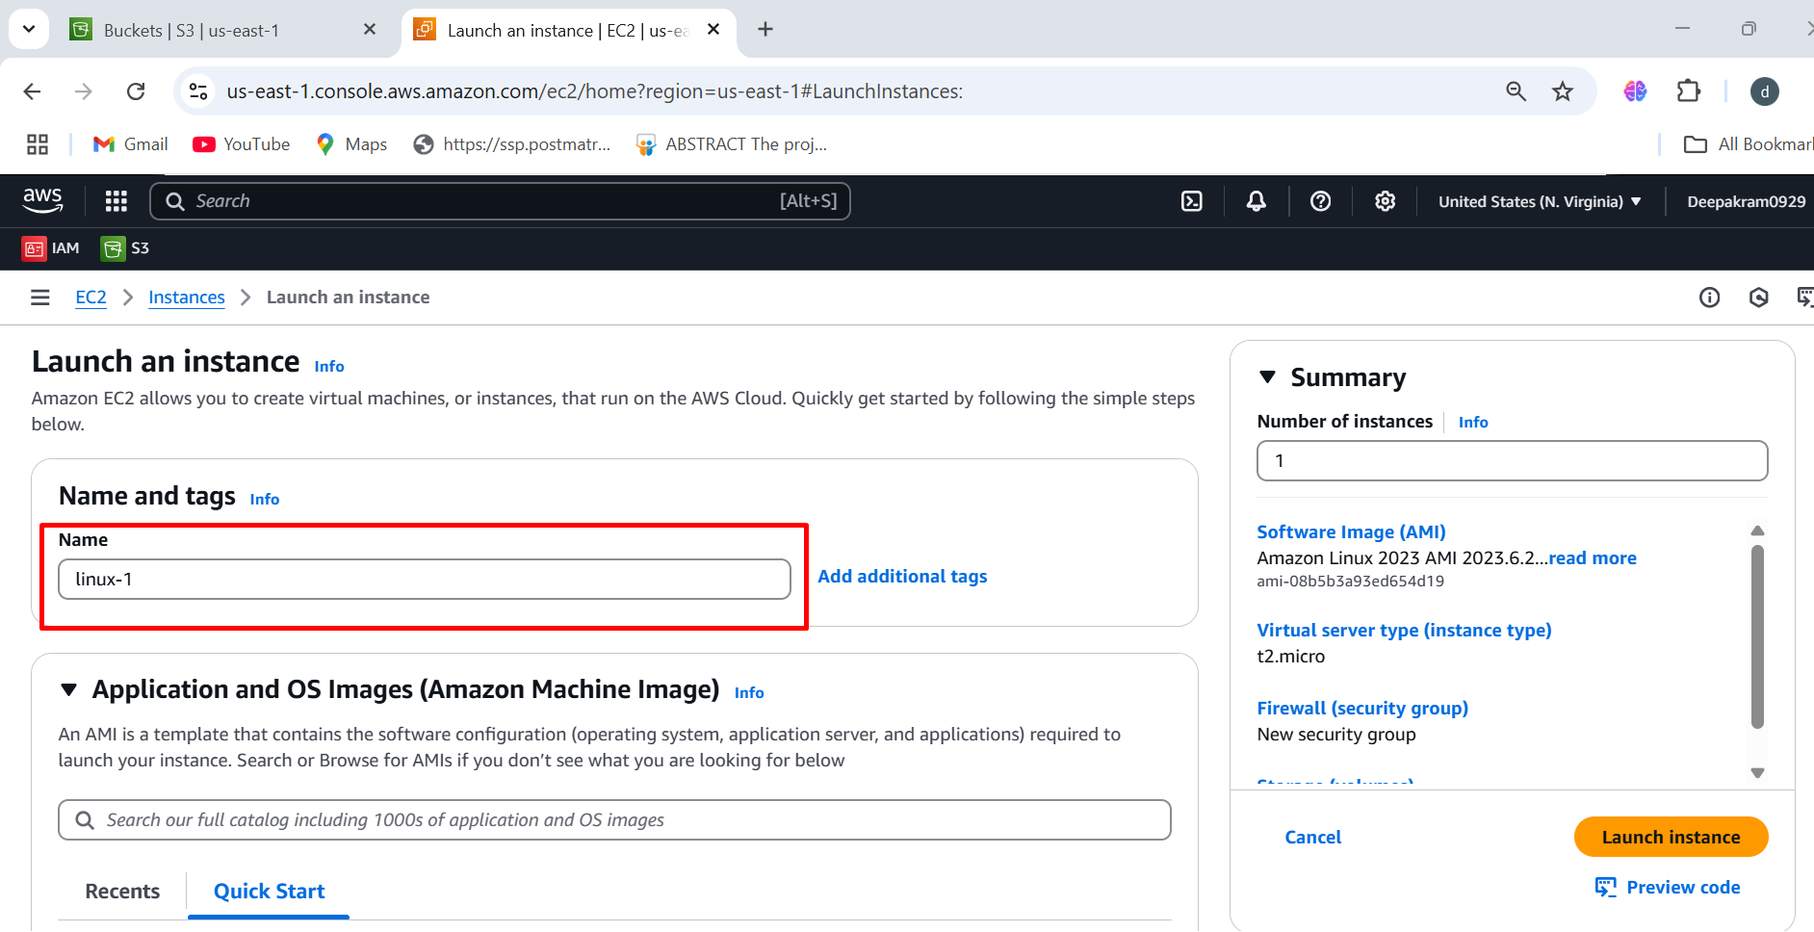

1. Choose the Amazon machine image **(Amazon Linux 2023 AMI)**

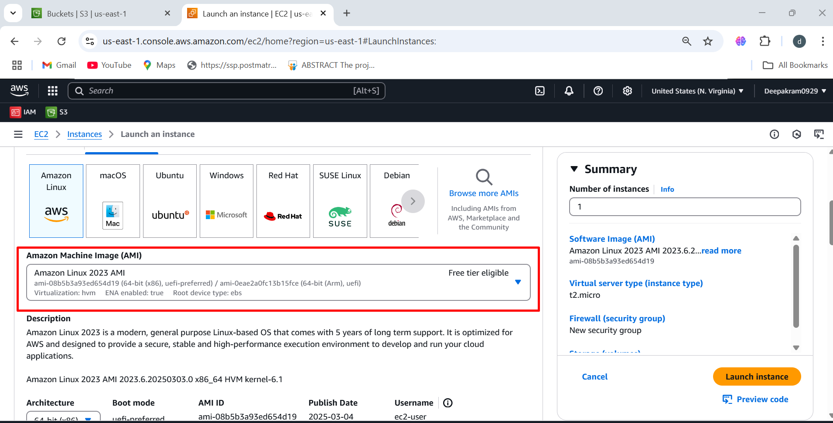

1. Architecture 🡪 Selected: 64-bit (x86)

This determines the CPU instruction set for the instance.

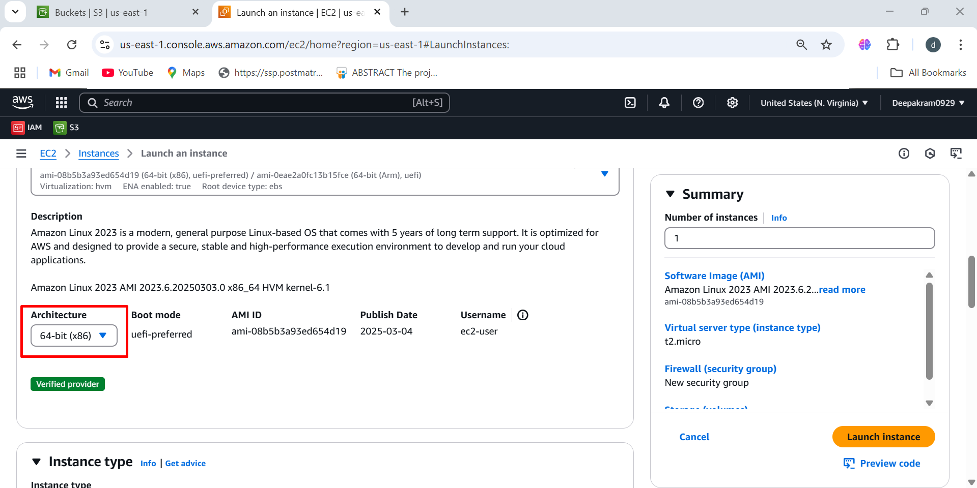

1. Select the instance type **(t2.micro 1cpu, 1GB RAM)**

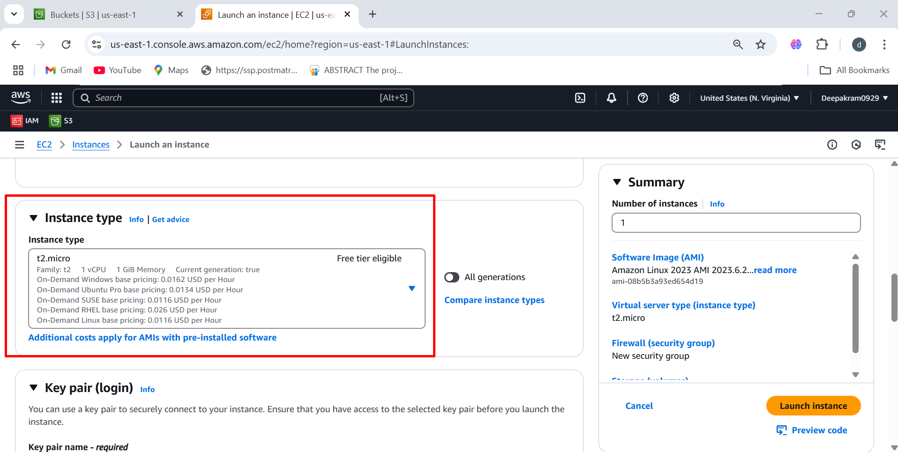

1. Select the existing keypair

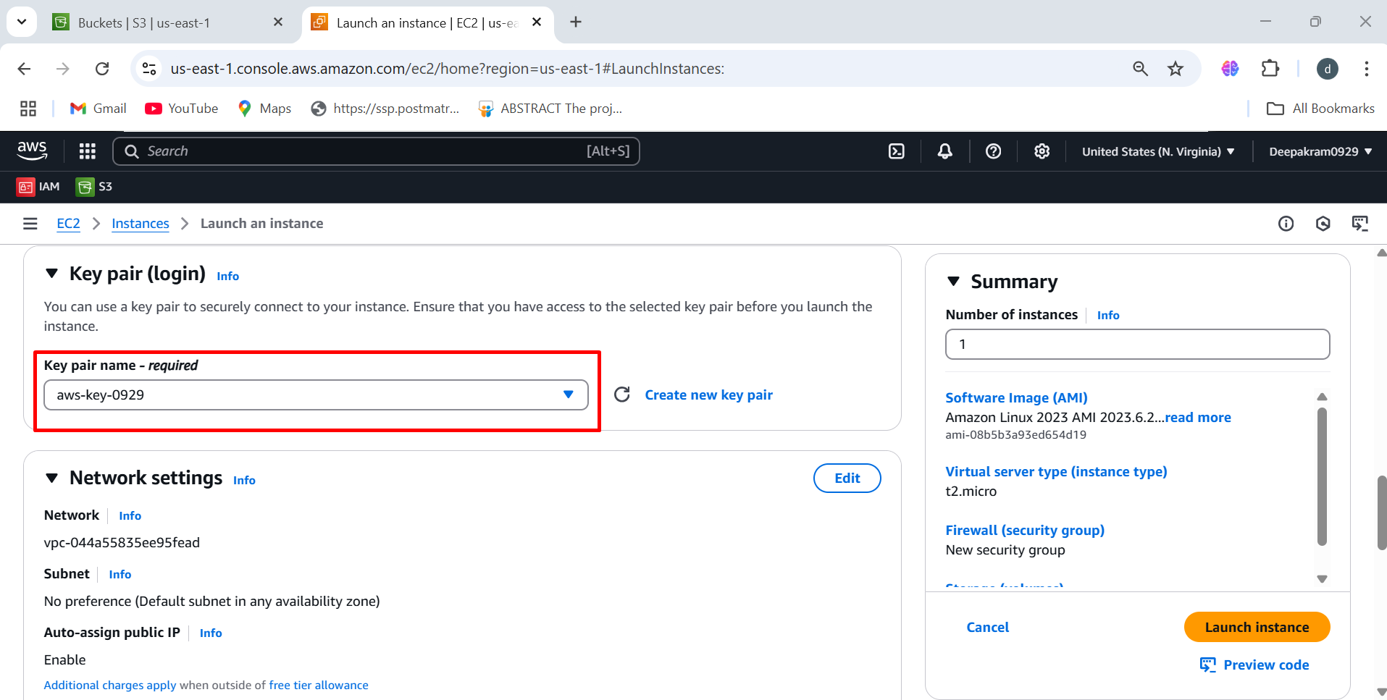

1. select existing security group 🡪 ssh-security-group

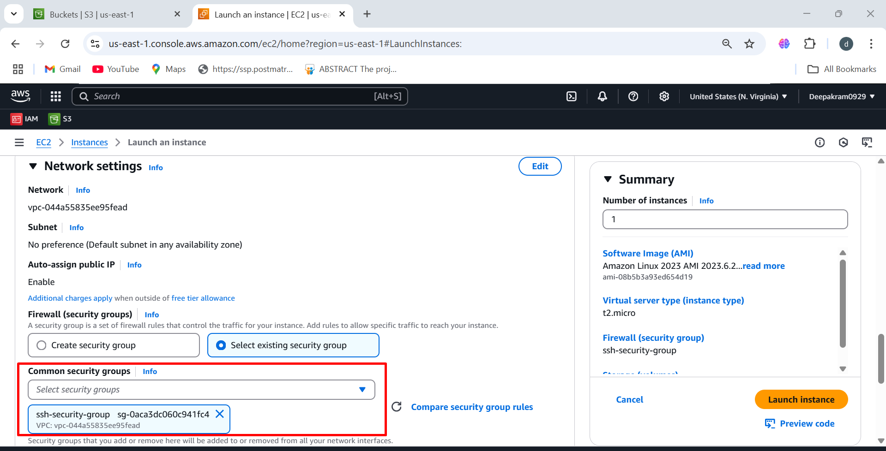

1. Select the storage 8 GB 🡪 launch instance

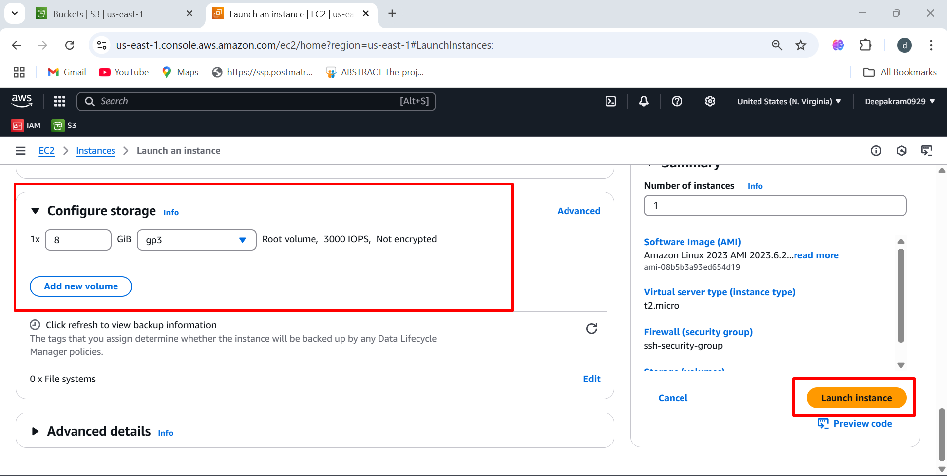

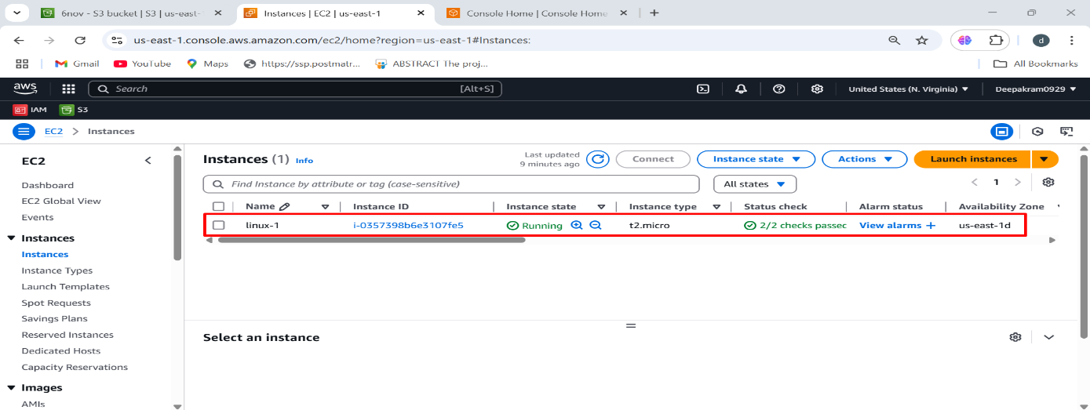

**TO ADD IAM ROLES AND POLICY**

IAM 🡪 Role 🡪 Create roles 🡪 AWS services 🡪 EC2 🡪 EC2 🡪 Next 🡪 Next 🡪 Role-Name 🡪 Create Role

IAM is used **to manage access and permissions for** AWS resources.

It allows creating **users, groups, roles, and policies** for security control.

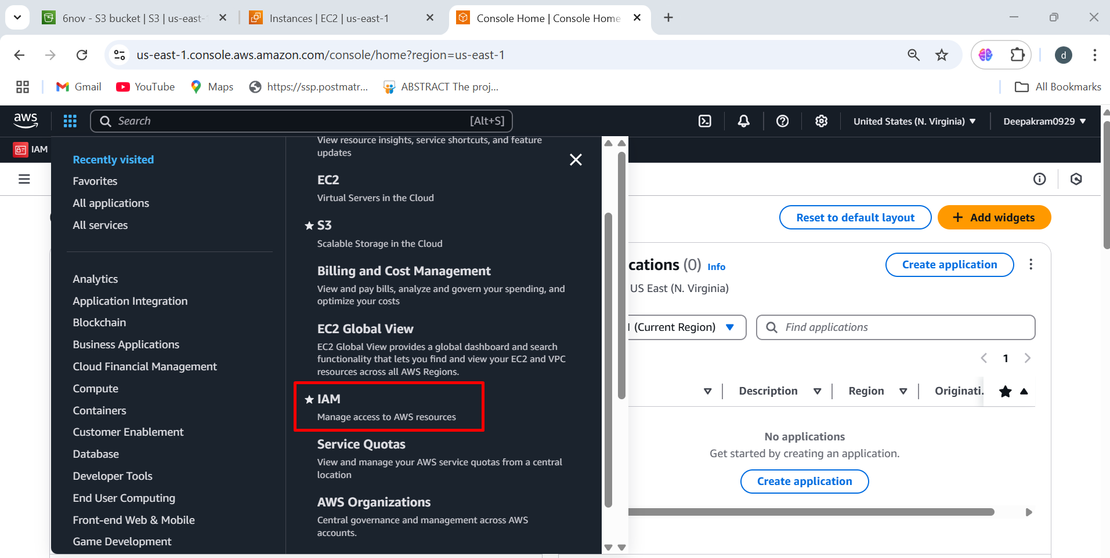

1. IAM Dashboard Overview 🡪 click on roles to assigning permissions

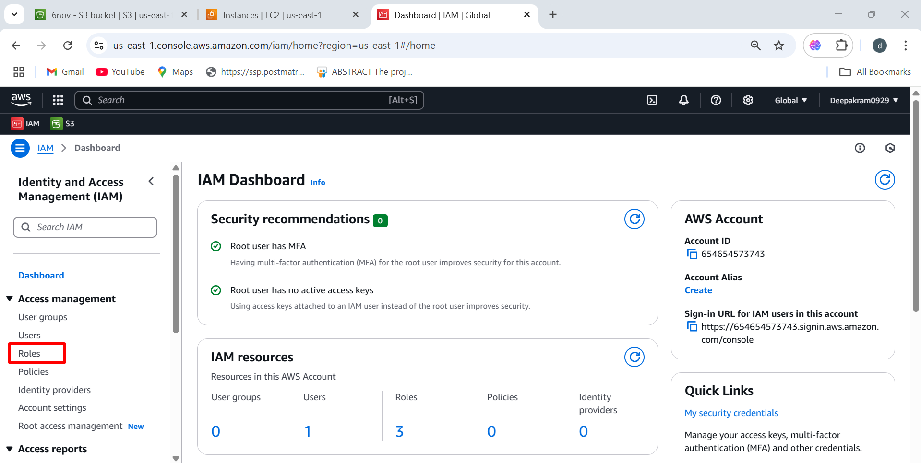

1. Click On Create Role Button 🡪 This is used to **create a new IAM role** with specific permissions.

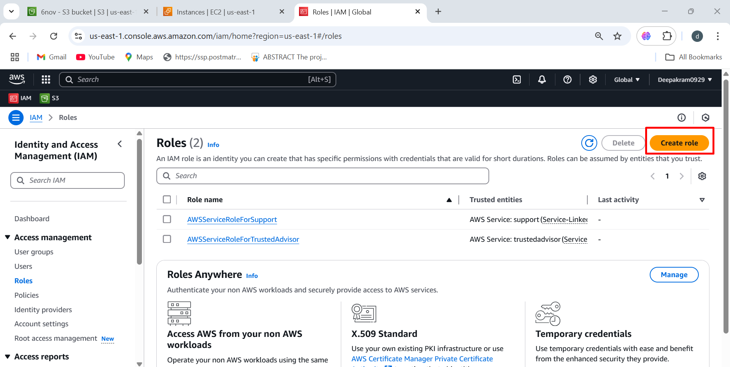

1. Select AWS service This allows AWS services like **EC2, others** to perform actions in the account.

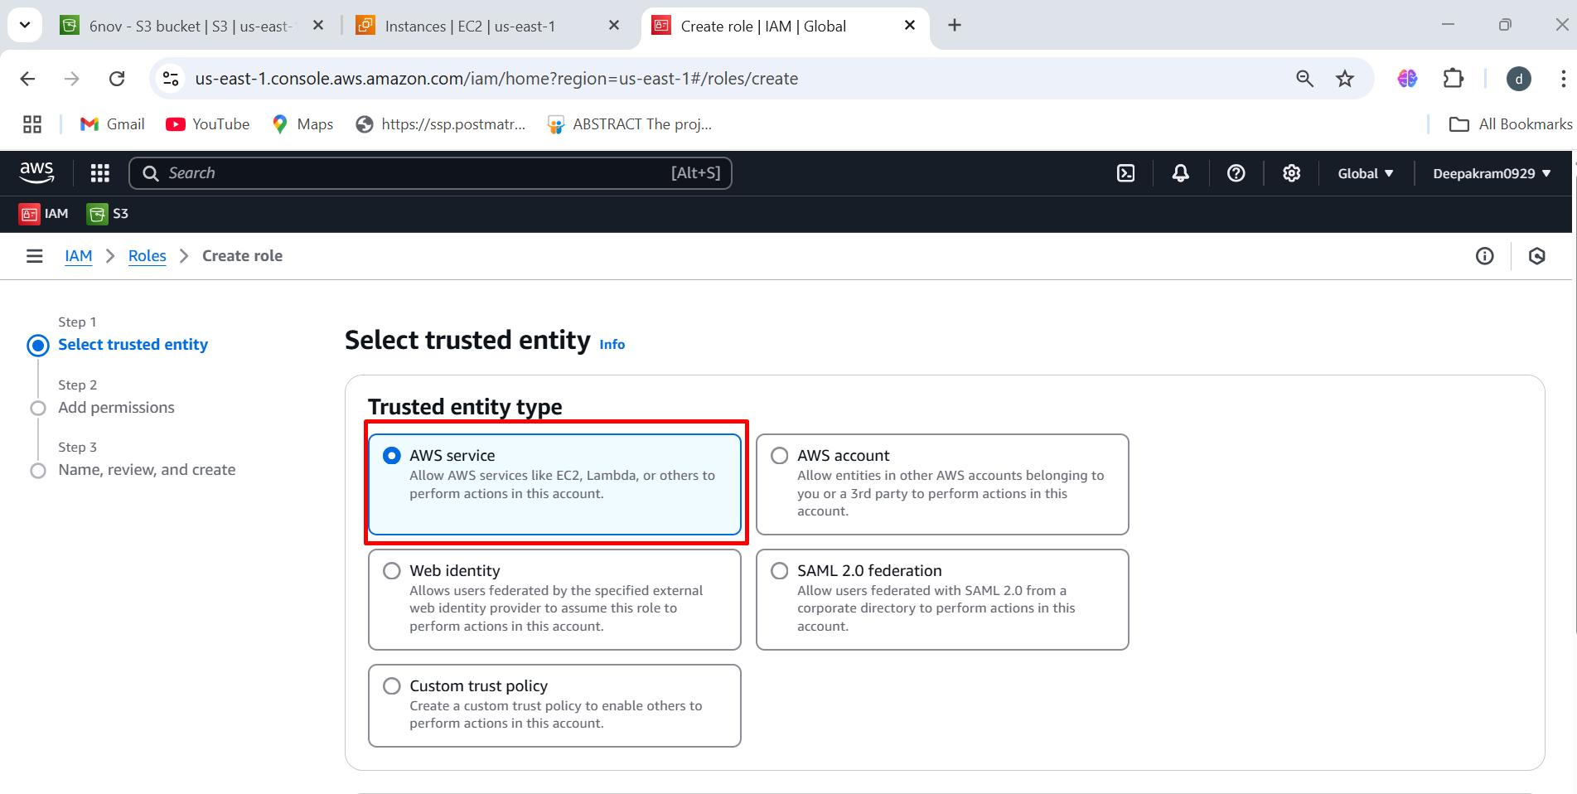

1. Select EC2 services

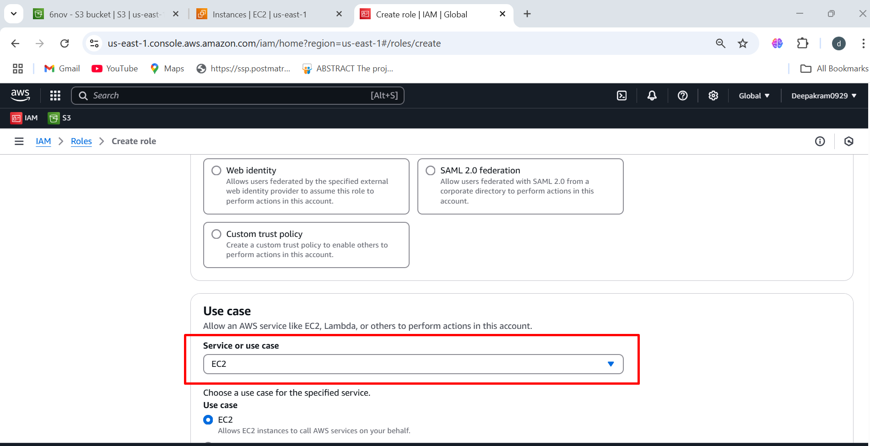

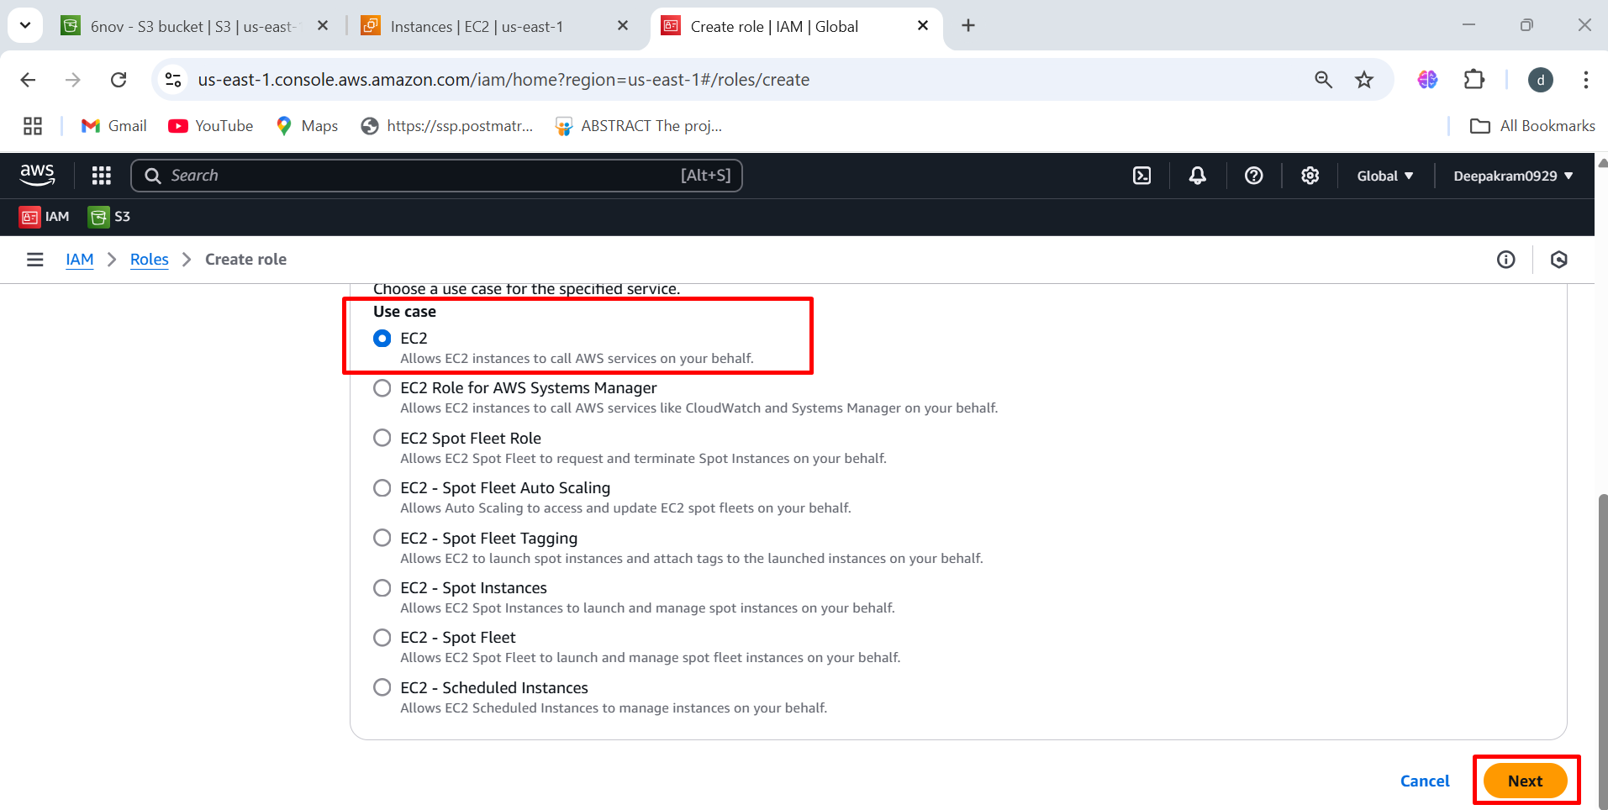

1. **Add Permissions**, you need to attach an appropriate **IAM policy** to define what actions the EC2 instance can perform.

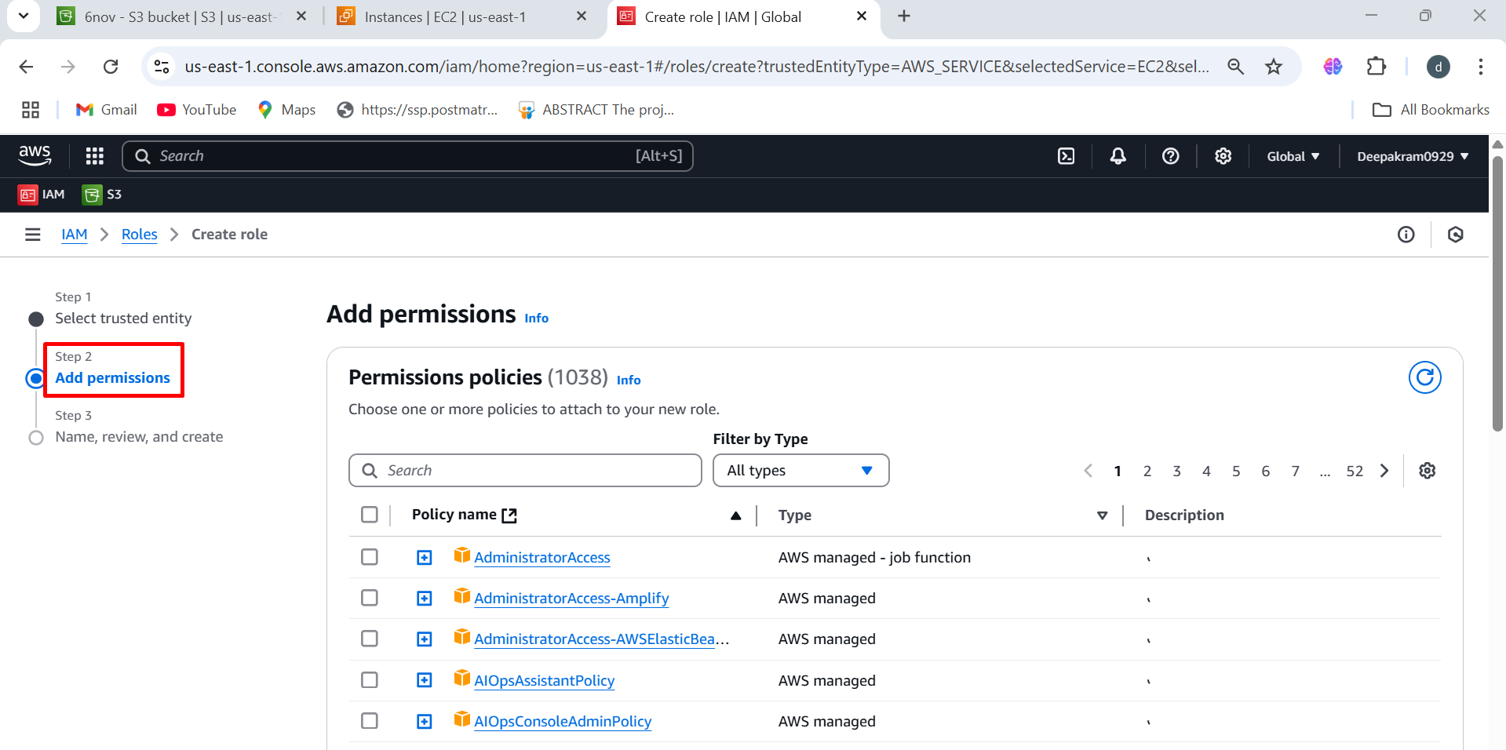

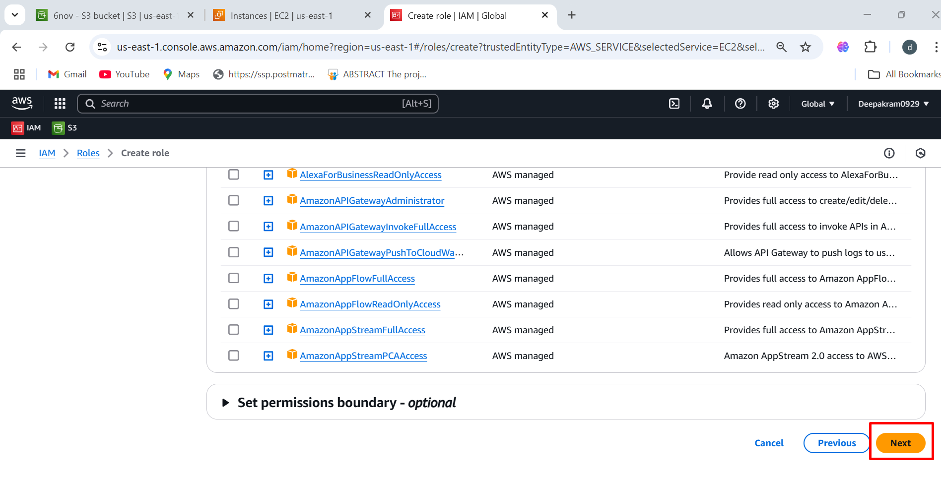

1. Enter the role name 🡪 "**ec2-to-s3-limited-access",** which suggests this role allows EC2 instances to access S3 with restricted permissions 🡪 click on create role

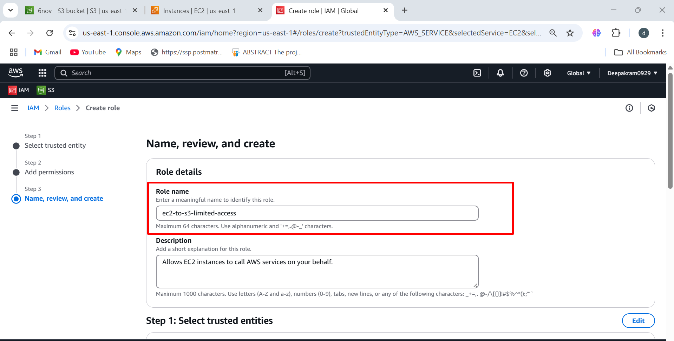

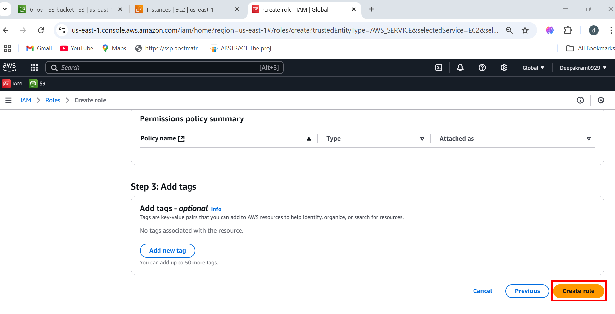

1. IAM role **"ec2-to-s3-limited-access"** has been successfully created! 🡪 Now that the role is created, you need to attach it to your EC2 instance to grant it the permissions.

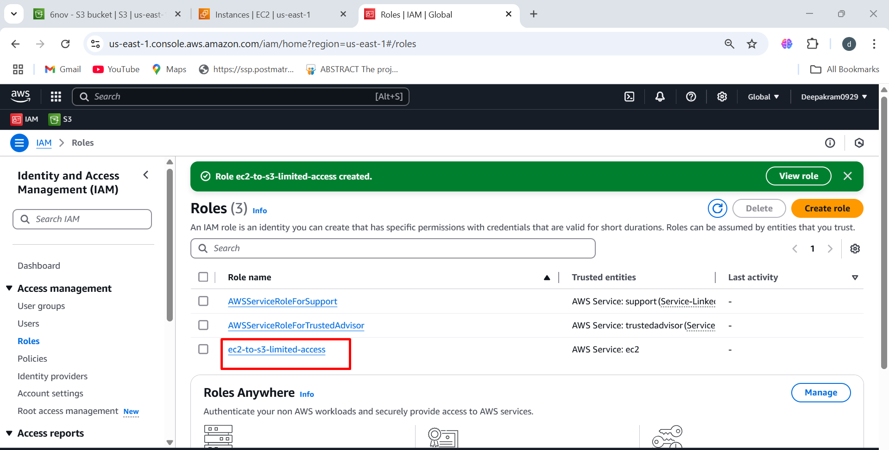

**ADD PERMISSIONS POLICY**

Role 🡪 open the role 🡪 Permission policies 🡪 add permissions 🡪 create inline policy 🡪 s3

1. Click on roles 🡪 Add permissions

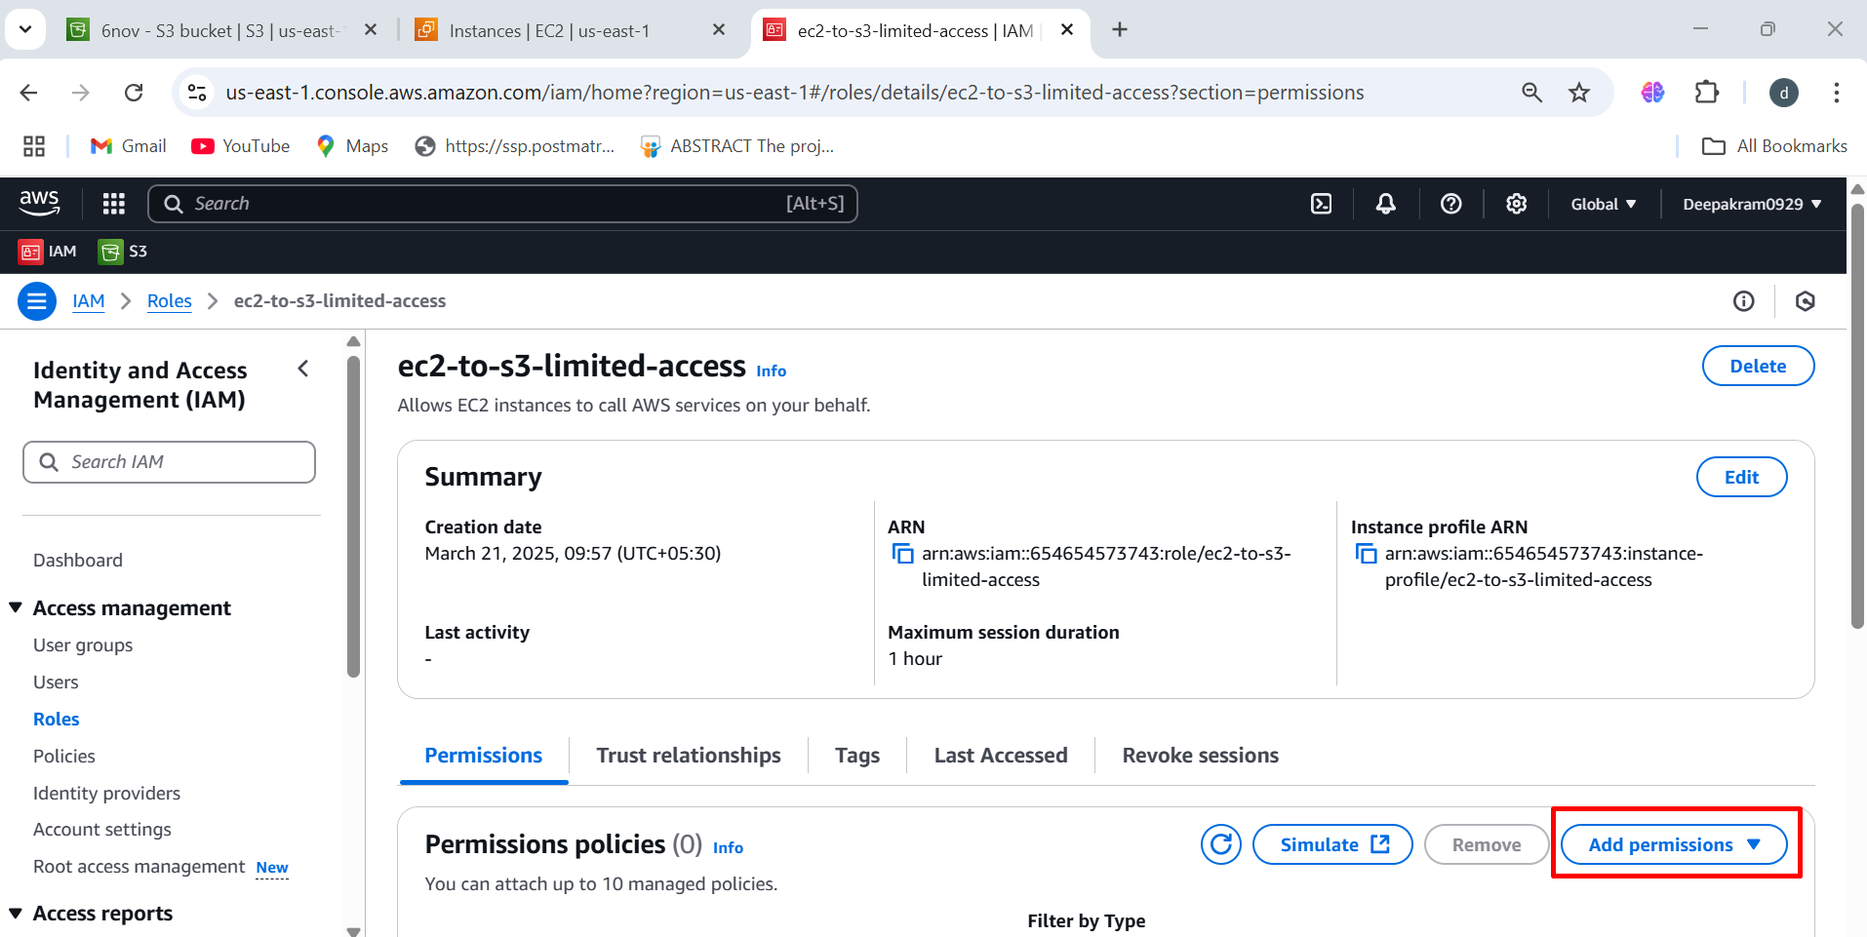

1. Now you are creating an **inline policy** for the **"ec2-to-s3-limited-access"** IAM role. This policy will define what actions the EC2 instance can perform on Amazon S3.

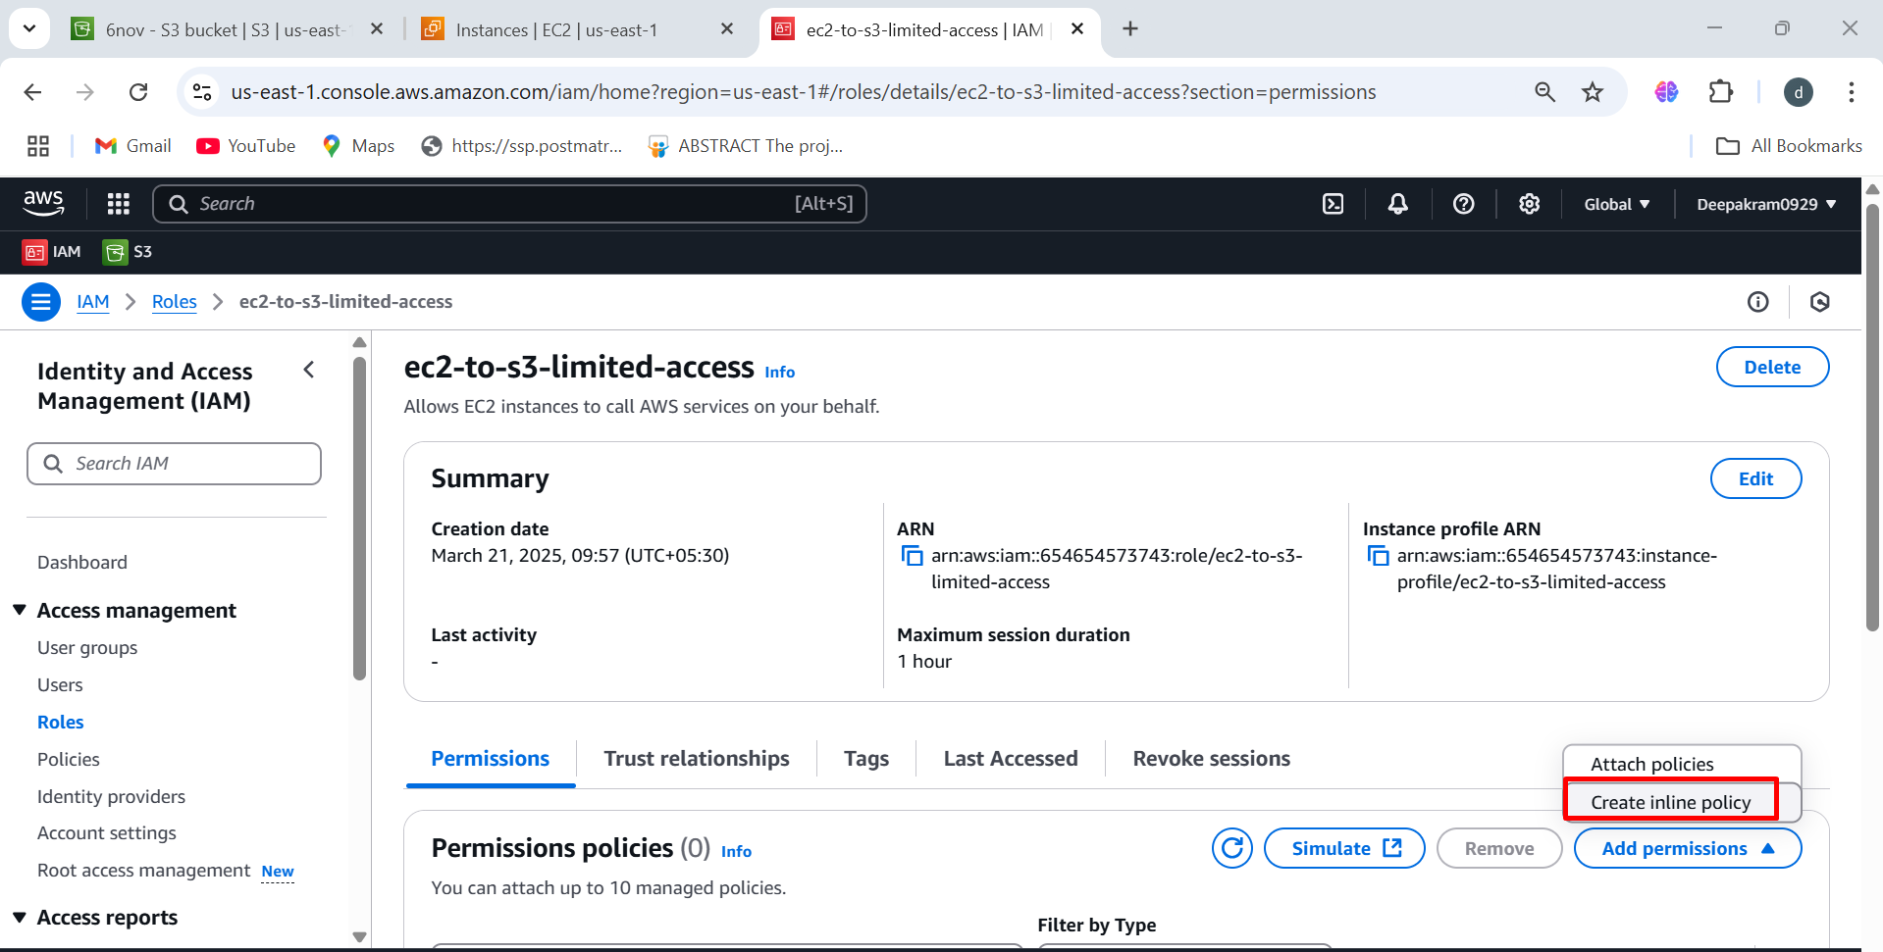

1. **select a service** for which you want to grant permissions. Since you are creating an inline policy for the **ec2-to-s3-limited-access** role,

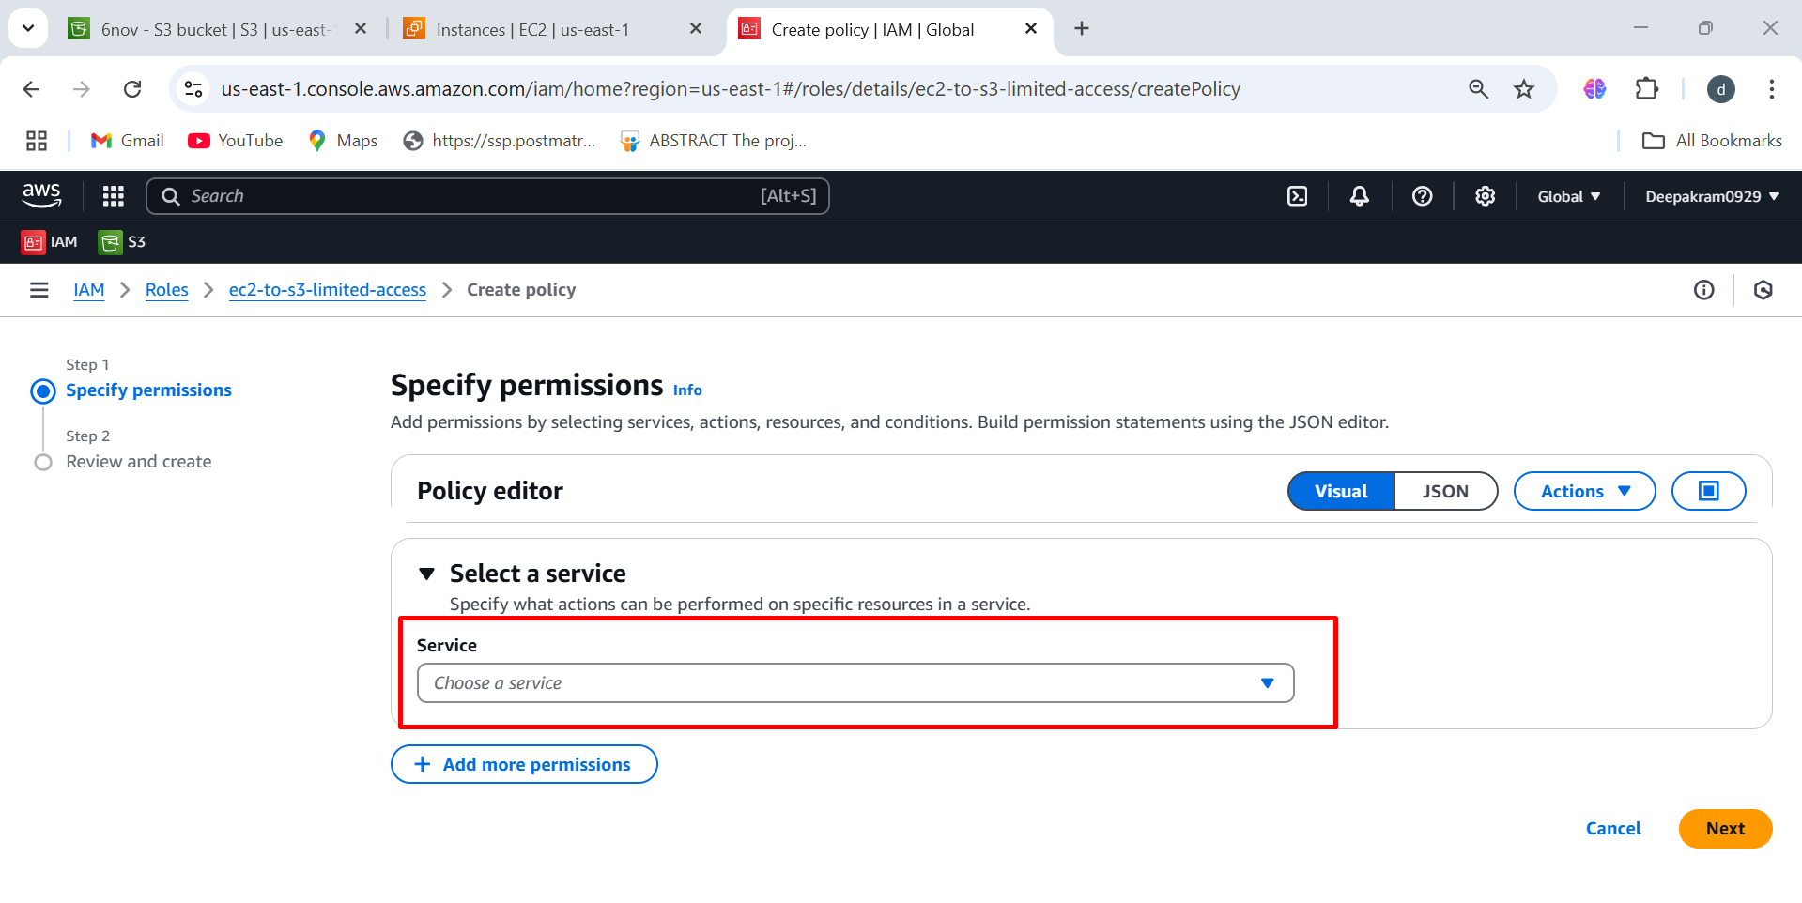

1. Set the permissions for s3

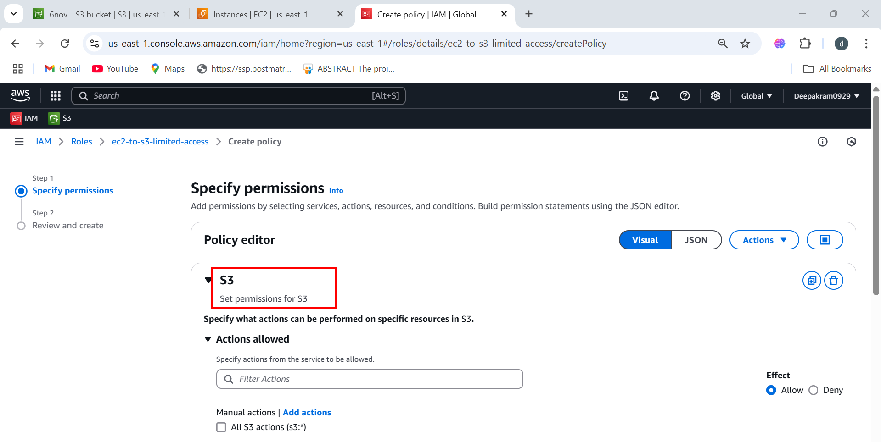

1. Choose the Actions (Permissions):

**List the contents of a specific S3 bucket** (s3:ListBucket)

**View all buckets in the AWS account** (s3:ListAllMyBuckets).

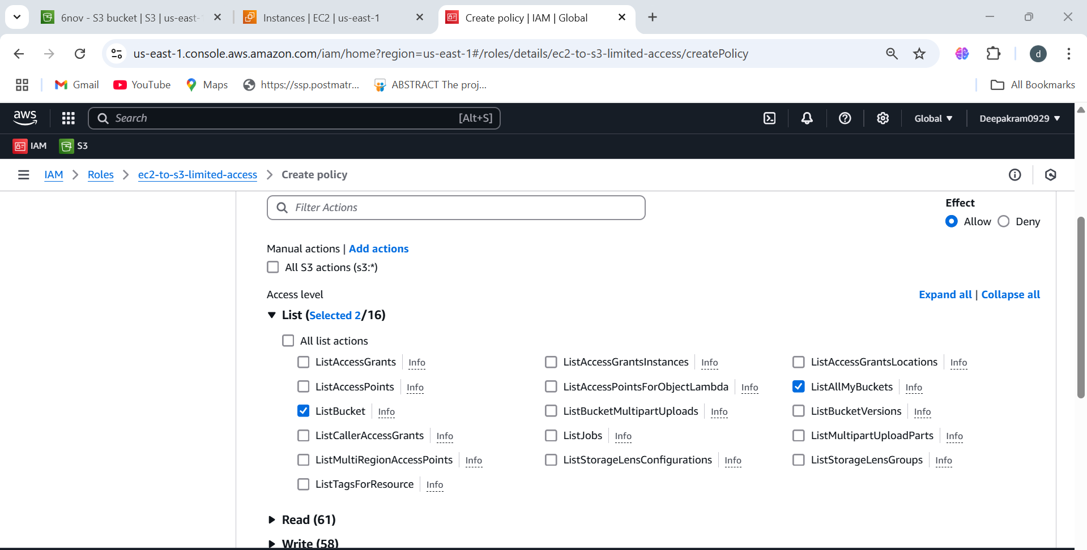

1. **Read** actions and select 🡪 GetObject (Allows downloading files from S3)

**Delete specific objects** from an S3 bucket (**DeleteObject**).

**Delete an entire S3 bucket** (**DeleteBucket**).

Uploads new objects to an S3 bucket (**PutObject)**

Allows the EC2 instance to **create new S3 buckets** (**CreateBucket)**

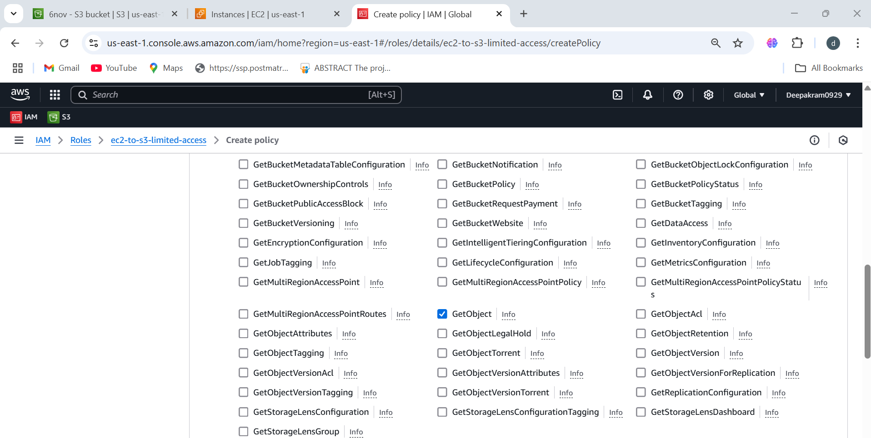

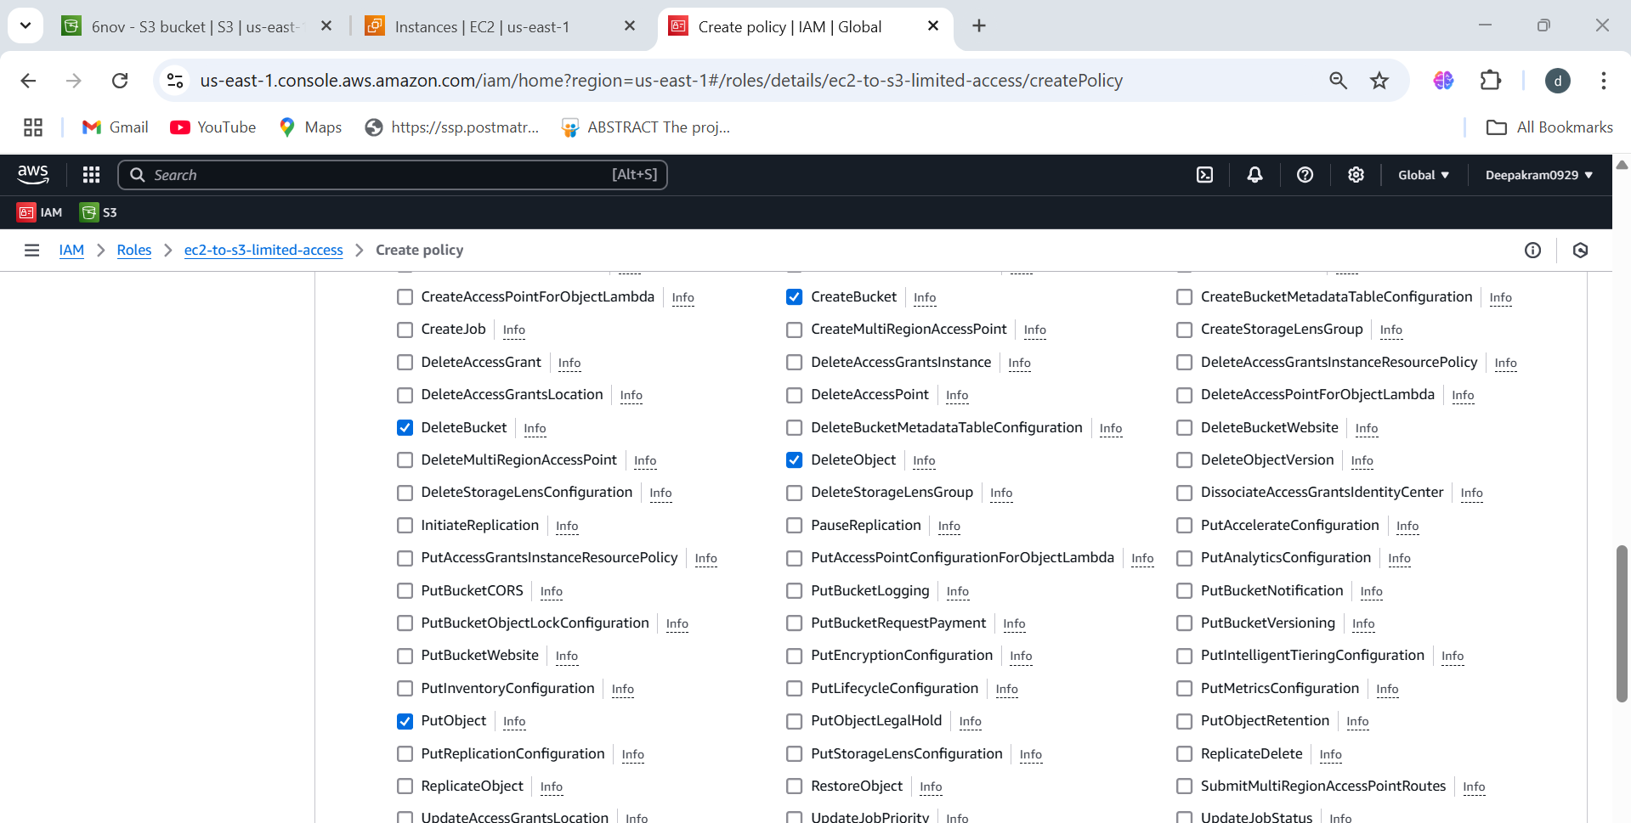

1. Selected Permissions Overview

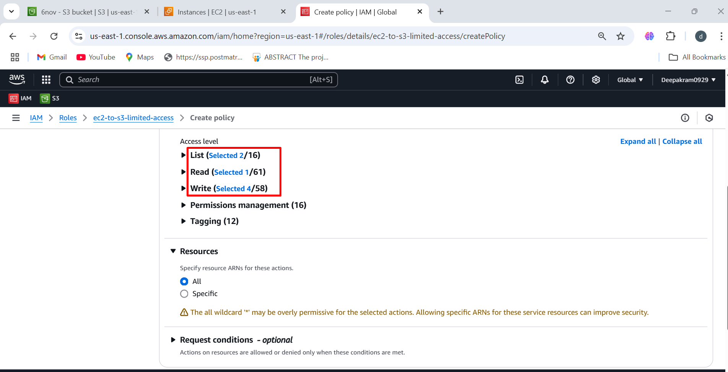

1. Need to specify **Amazon Resource Names (ARNs)** for **buckets and objects** to restrict access.

Click **"Add ARNs"** under the **bucket** section to specify the **S3 bucket(s)** this IAM role should access.

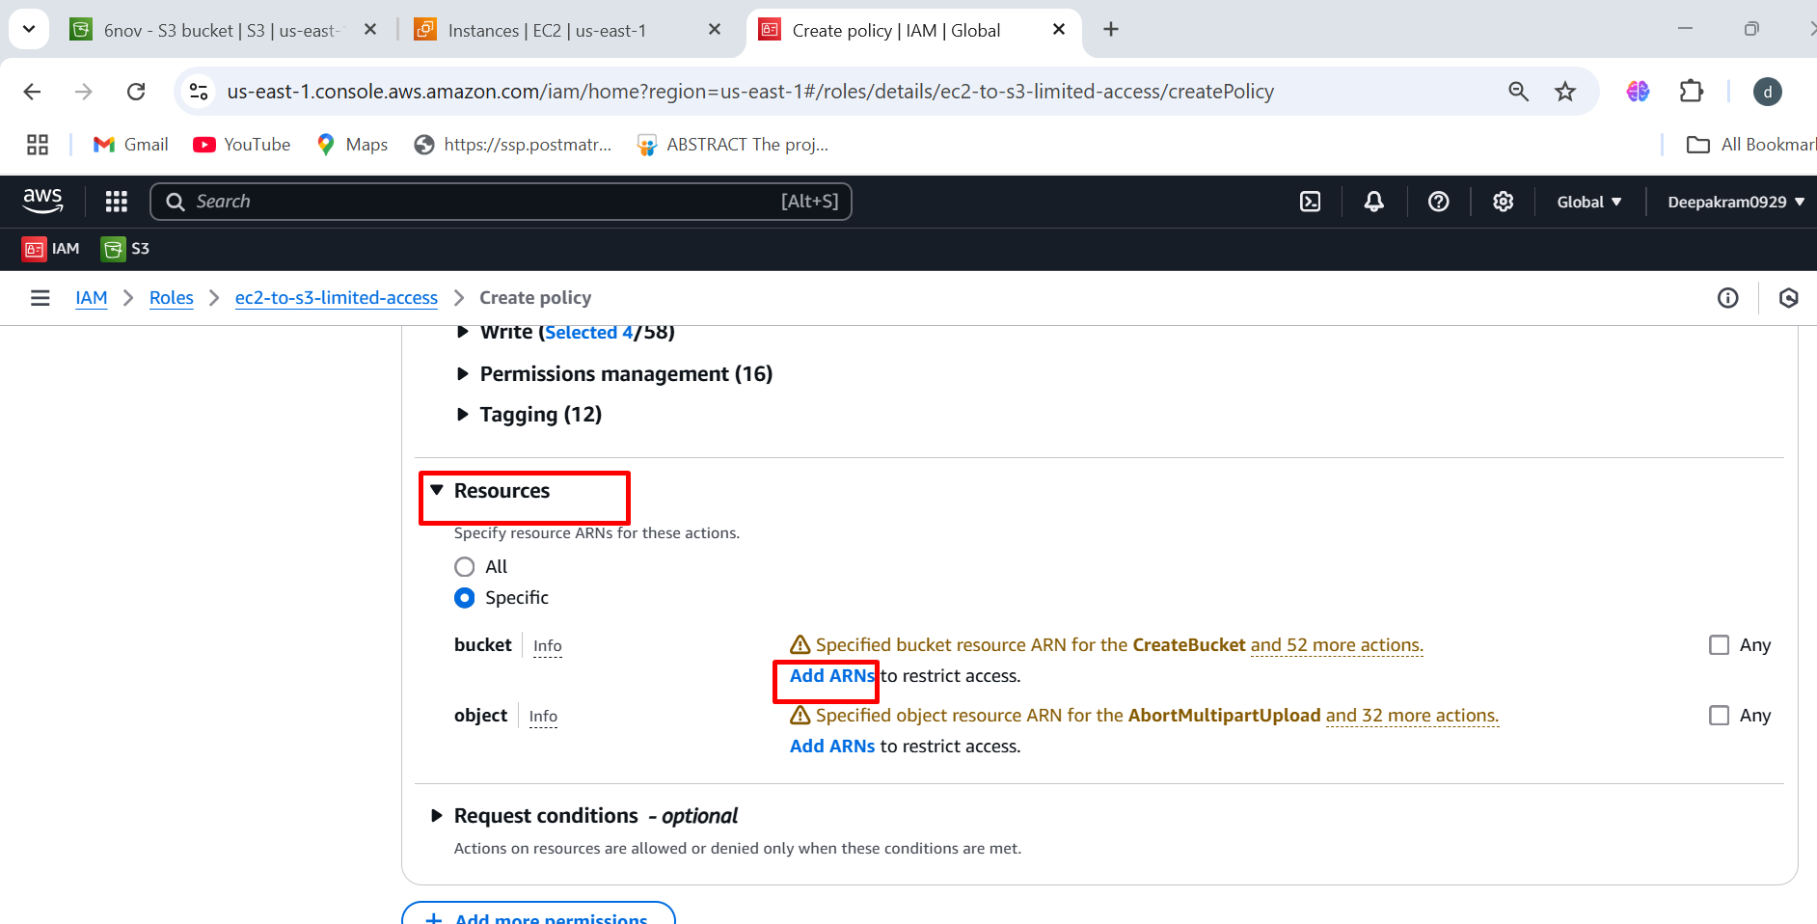

1. Click **"Add ARNs"** under the **object** section.

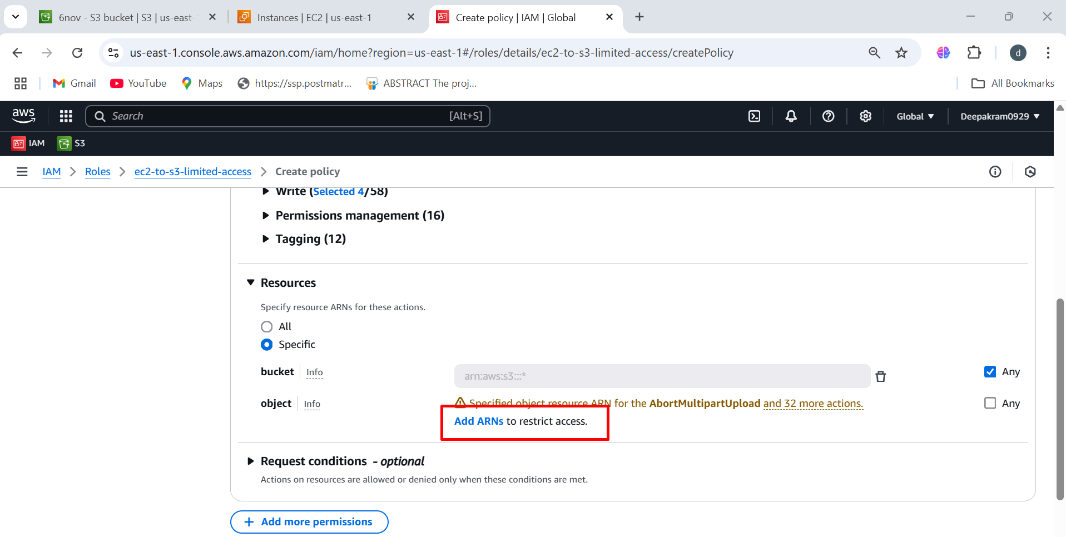

1. Enter the Bucket Name or Replace * with your actual **S3 bucket name** If you want access to all buckets

Enter the Object Name or If you want to grant access to all objects in the bucket, enter *

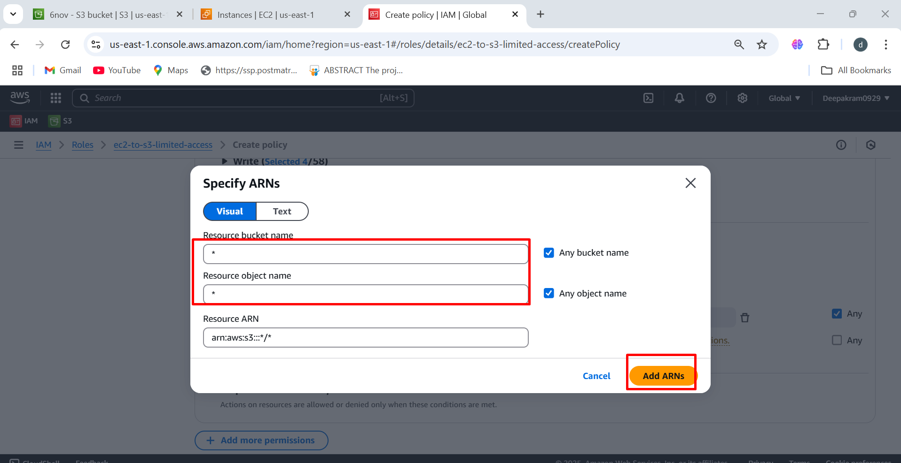

1. Bucket ARN: arn:aws:s3:::* → Grants access to all S3 buckets.

Object ARN: arn:aws:s3:::*/* → Grants access to all objects in all buckets.

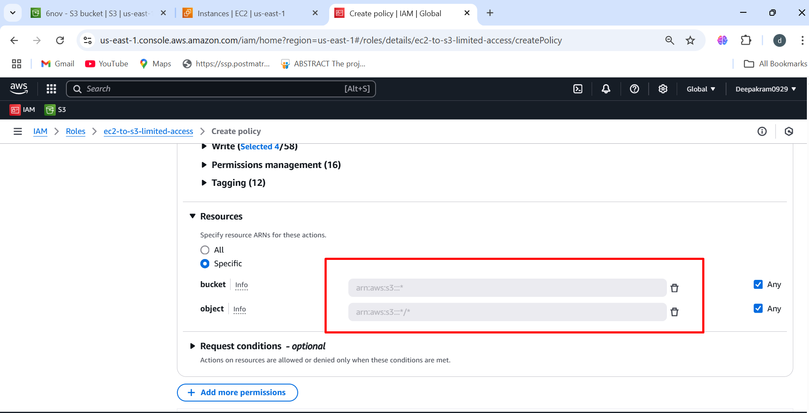

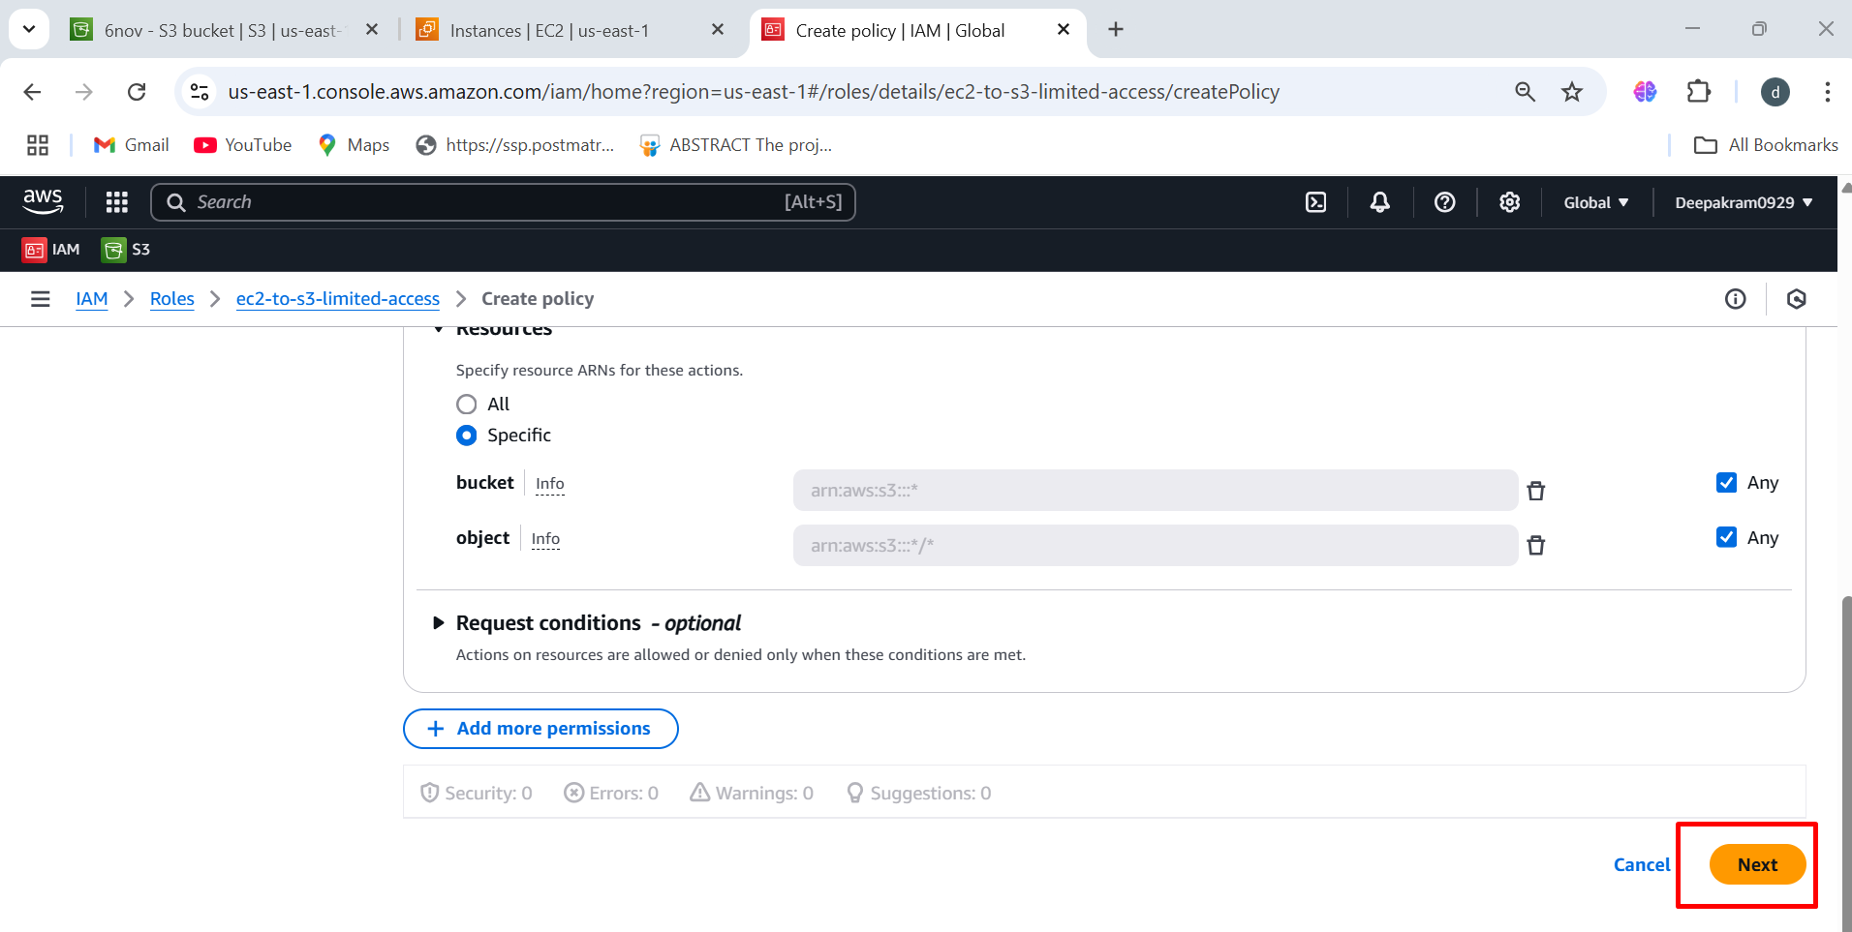

1. Enter the policy name 🡪 click on create policy

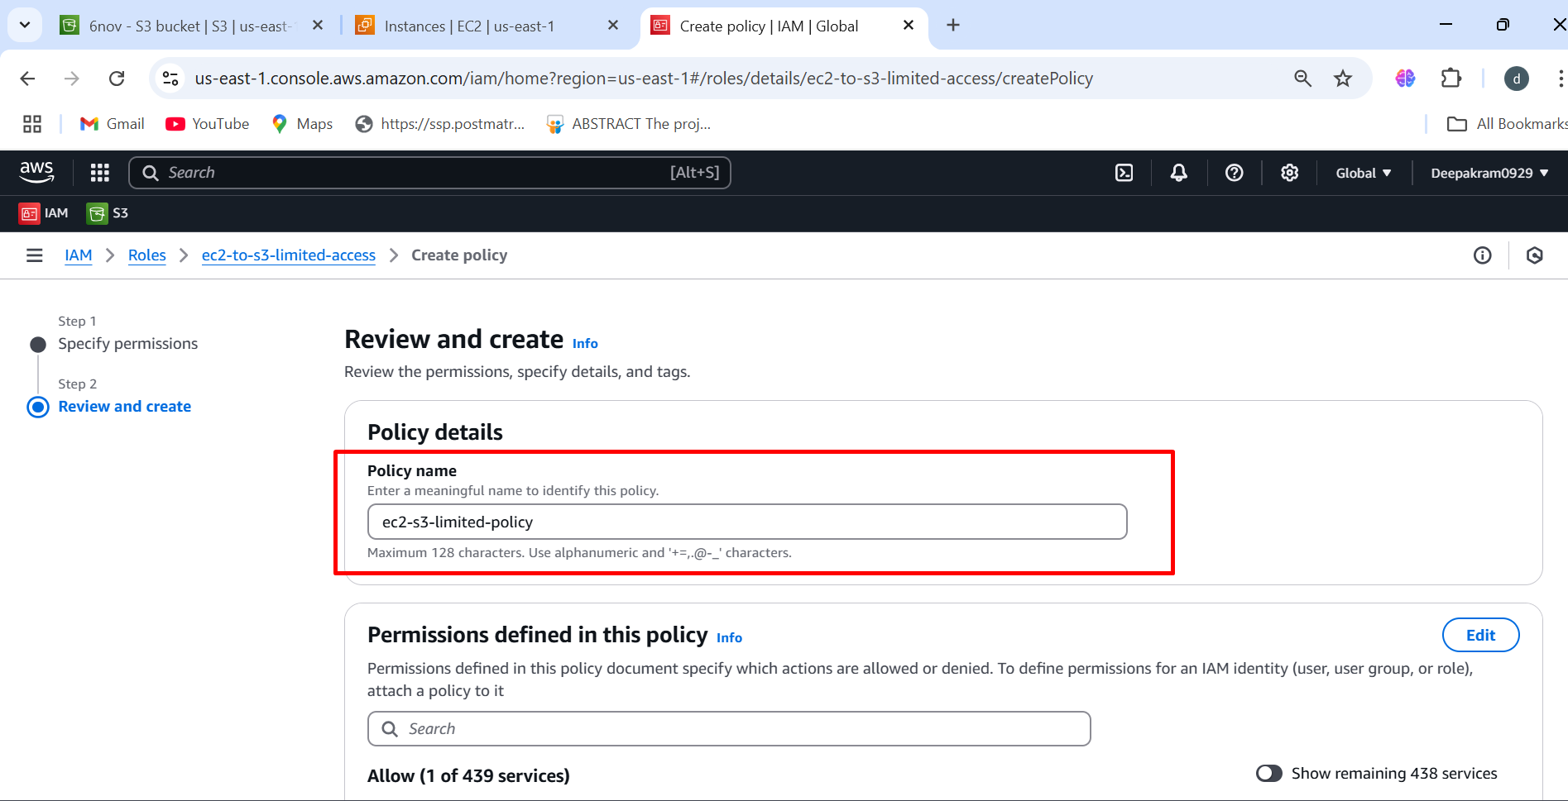

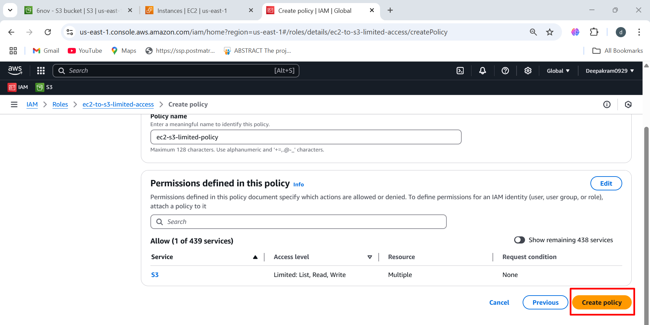

1. **"ec2-s3-limited-policy"** has been successfully created.

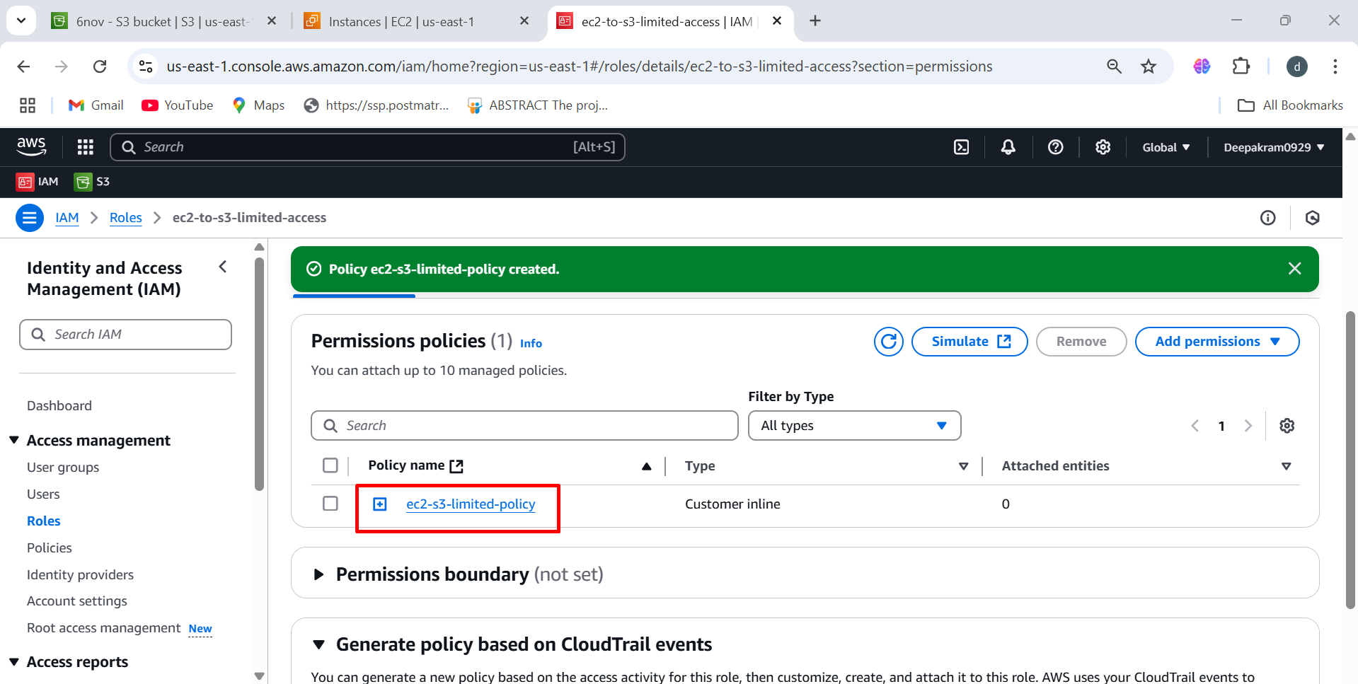

1. Select the instance 🡪 Click on actions 🡪 select security 🡪 modify IAM role

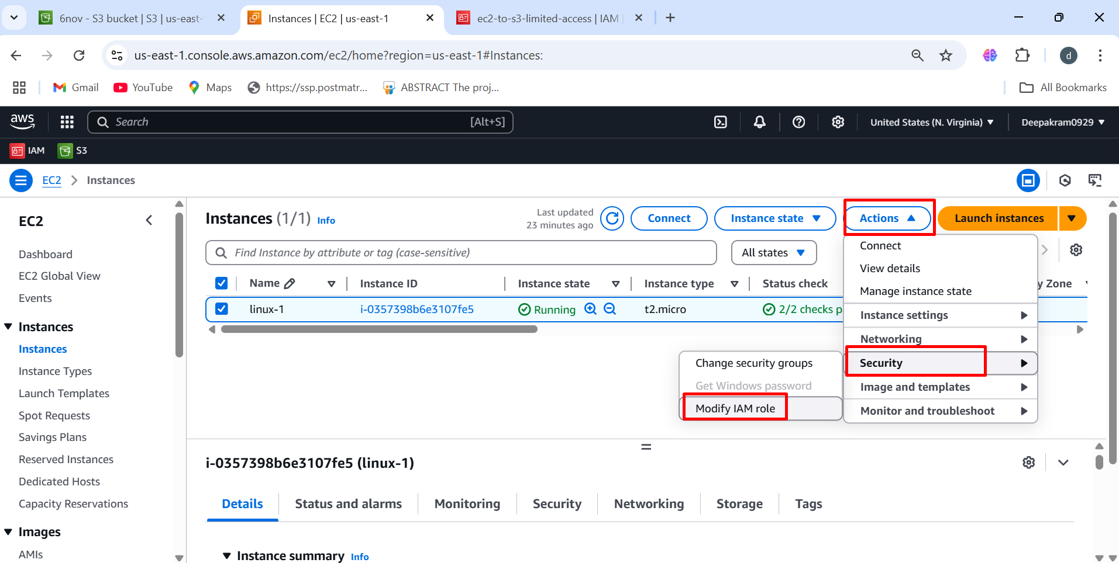

1. Select the IAM role which we created previously and update IAM role

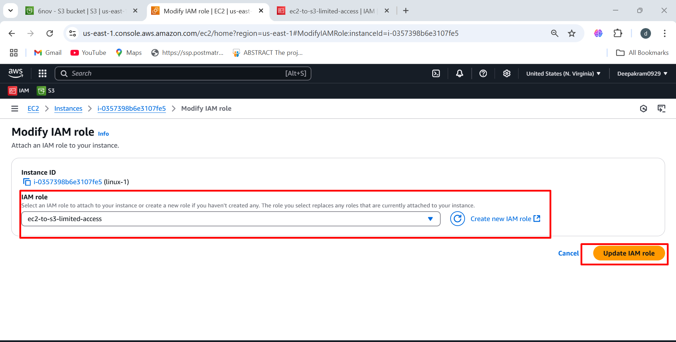

1. Confirming that the **IAM role has been successfully attached** to an EC2 instance.

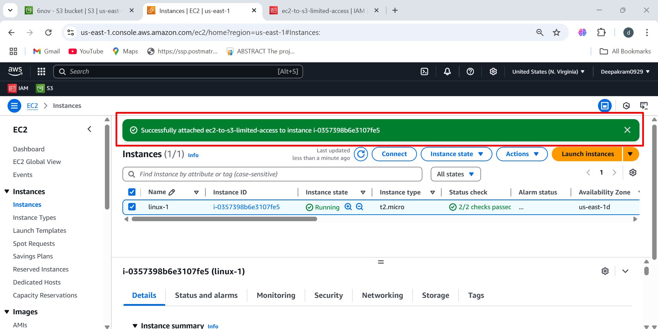

**Connecting to a Linux-1 EC2 Instance using Mobaxterm software**

Launch **MobaXterm** on your Windows system. 🡪 Start a New SSH Session 🡪 Click on **"Session"** (top-left corner) 🡪 Select **"SSH"** from the session type 🡪 **Remote Host**: Enter the **IP address** or **hostname** of your Linux system 🡪 **Specify Username**: **Linux username (ec2-user)** 🡪 Advance ssh setting 🡪 Upload the **private key** (.pem) 🡪 Click on ok

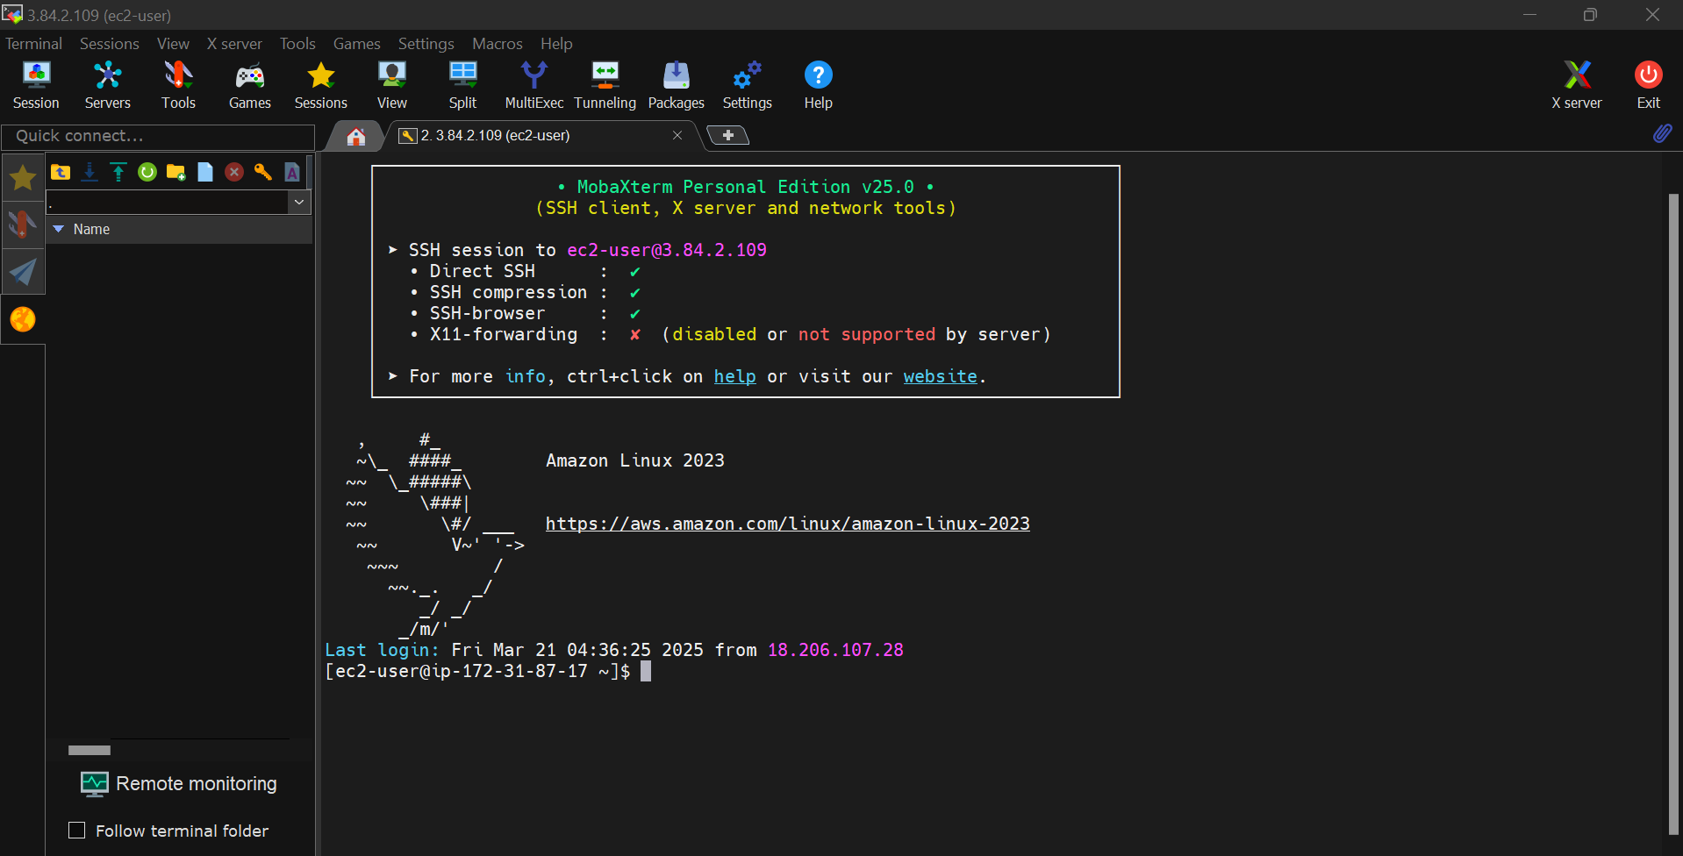

1. To list buckets 🡪 aws s3 ls

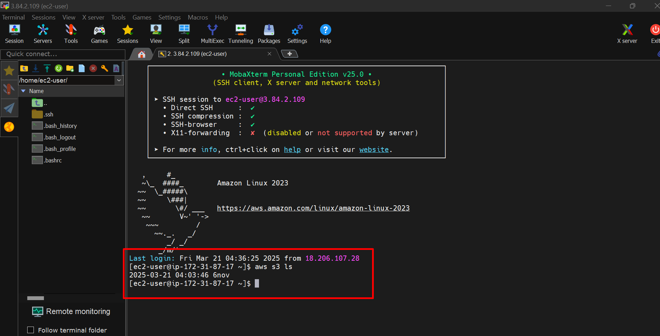

1. To list objects inside the bucket 🡪 aws s3 ls s3://<bucket-name>

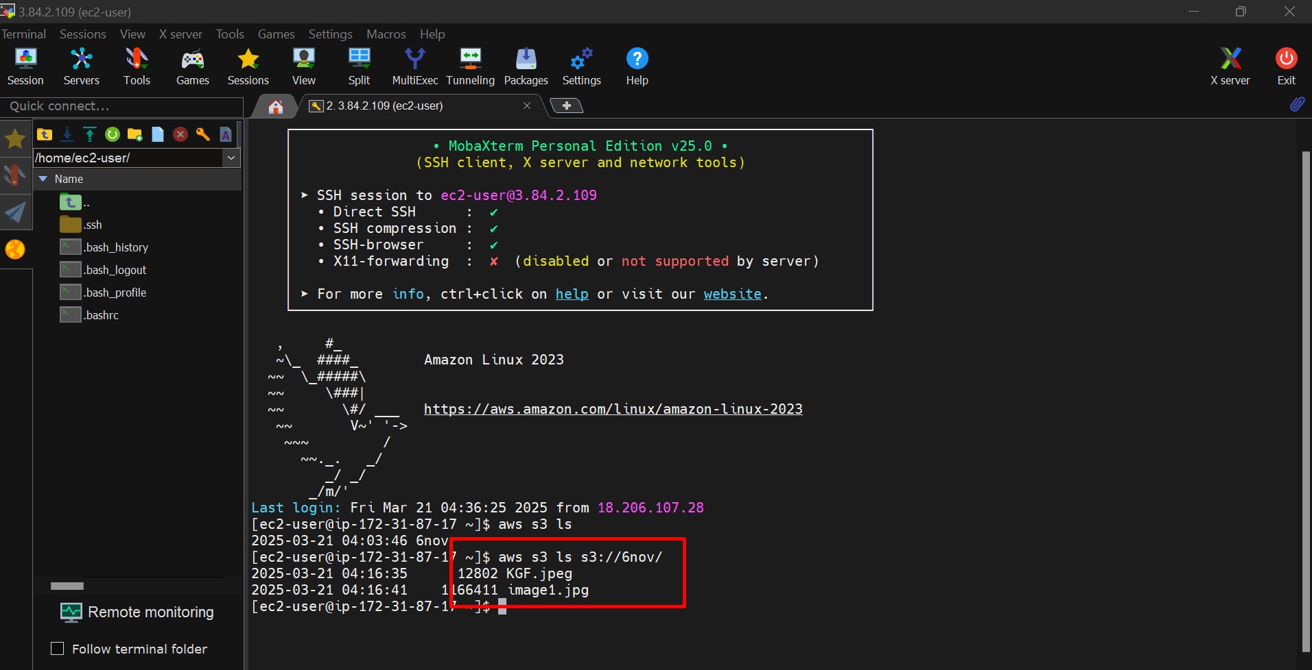

1. To create new bucket 🡪 aws s3 mb s3://<bucket-name>

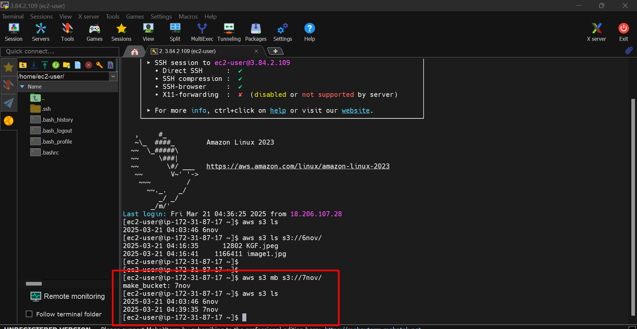

1. Displaying the list of S3 buckets

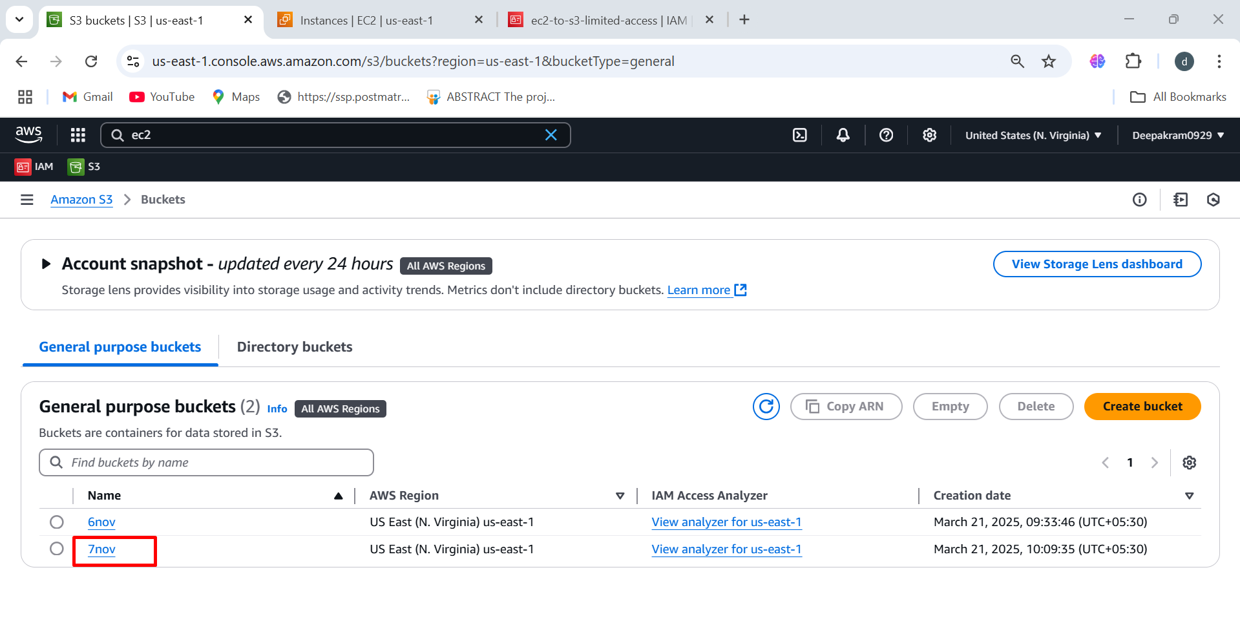

1. Creates a directory named **dir1🡪** mkdir dir1

touch index{1..5}.html → Creates multiple HTML files (**index1.html, index2.html, ..., index5.html**)

Uploads single **index1.html** to the **"6nov"** S3 bucket

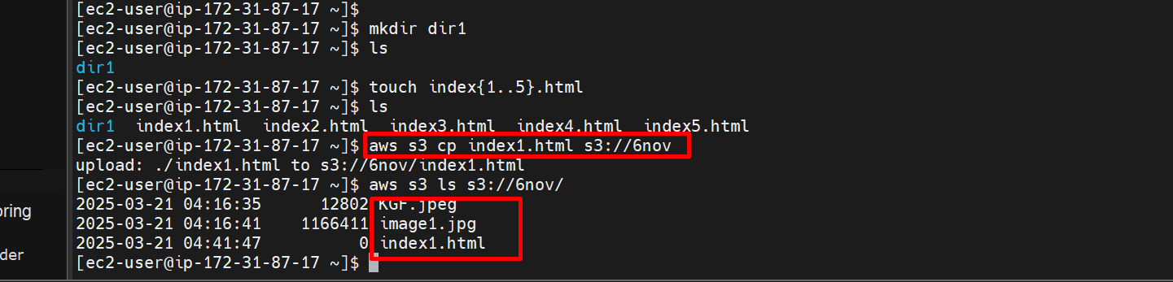

1. Objects Inside the Bucket 🡪 Successfully file as been upload

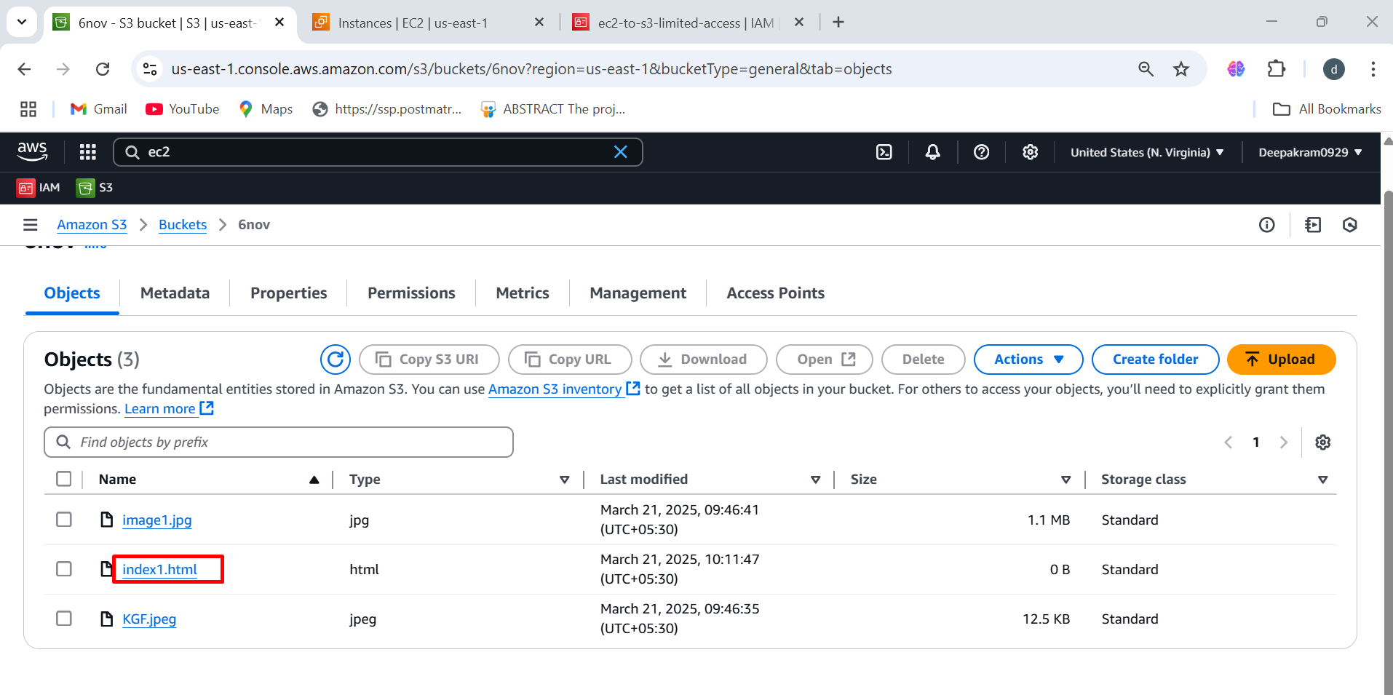

1. aws s3 sync /home/ec2-user/ s3://6nov/ 🡪 This command **synchronizes** (uploads) all files from /home/ec2-user/ to the S3 bucket "6nov"

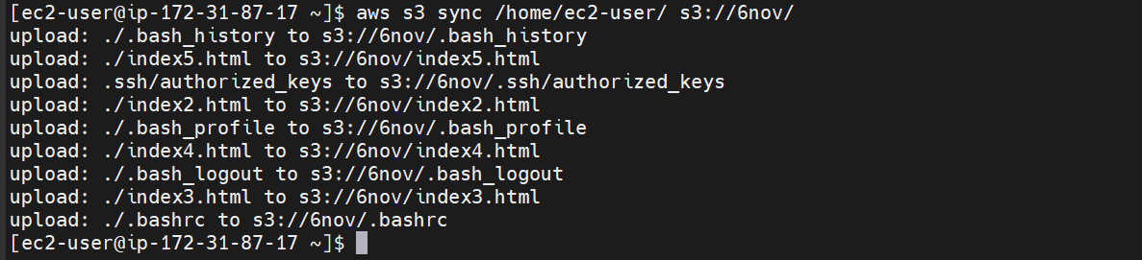

to upload specific files from ec2 to s3 🡪 to download all files from s3 to ec2 🡪 to upload all file from ec2 to s3 🡪 to upload specific files from ec2 to s3 🡪 to delete multiple files

We not have full access permissions

To access s3 full permission we need to add IAM role with Amazons3FullAccess

1. Create new role

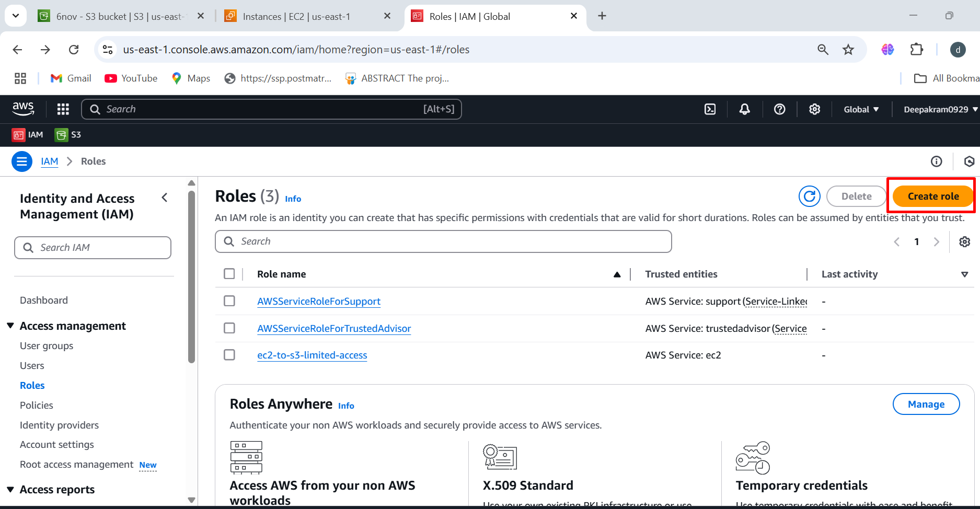

1. Click on AWS services

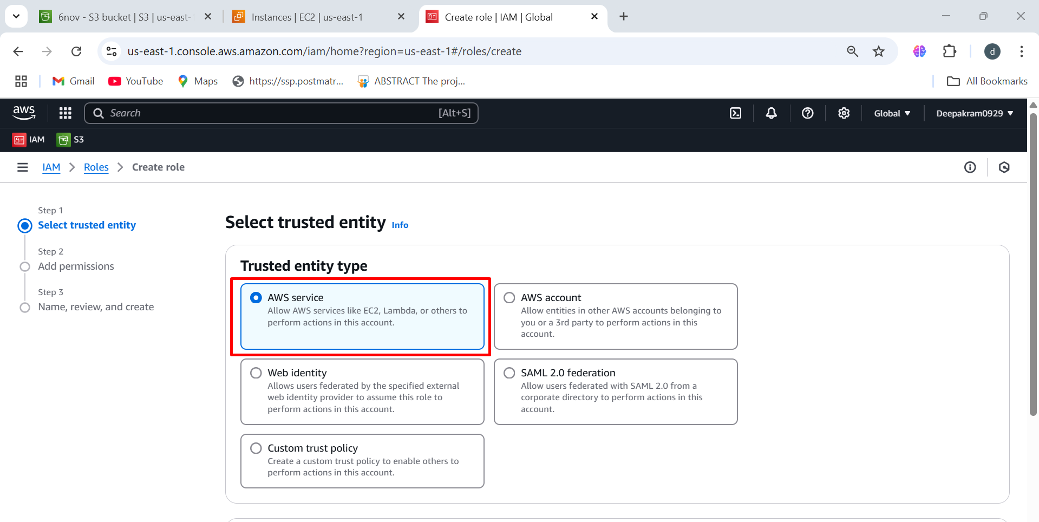

1. Select the ec2 services 🡪 click on next 🡪 Add permissions 🡪 Select AmazonS3FullAccess

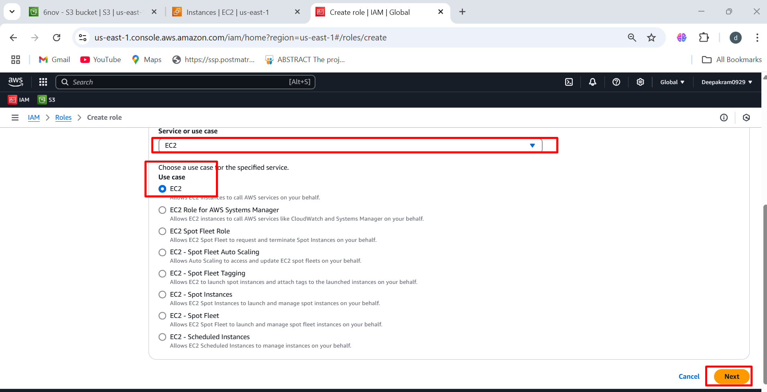

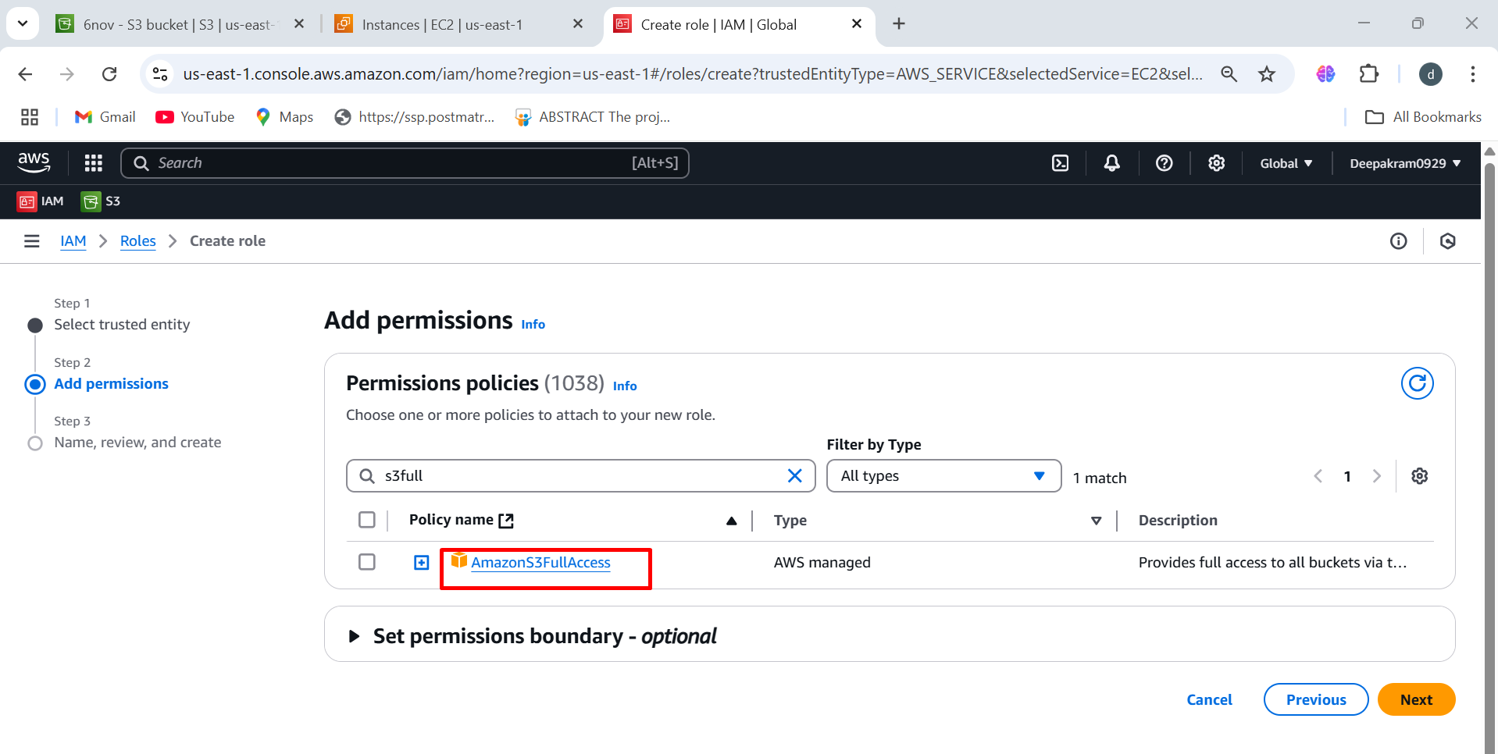

1. Select the permission and click on next

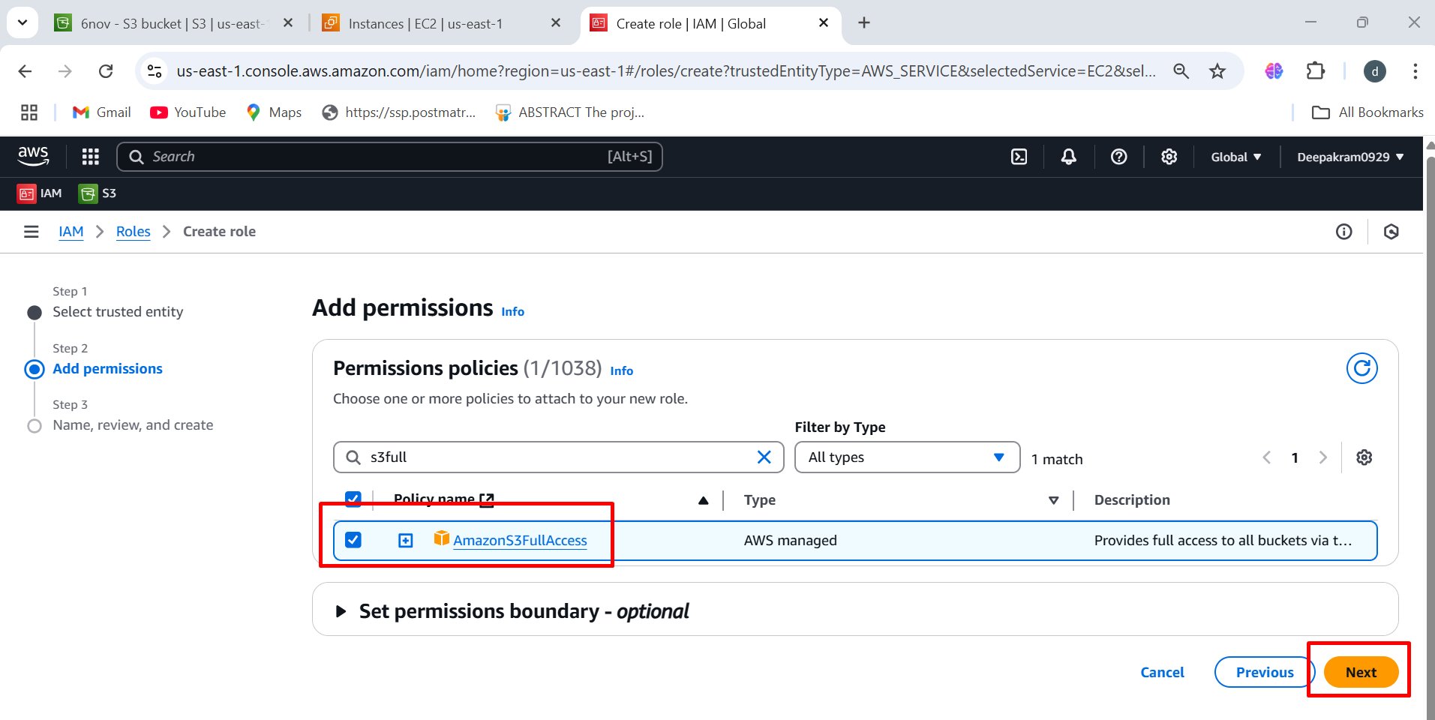

1. Select the policy and create role for that policy

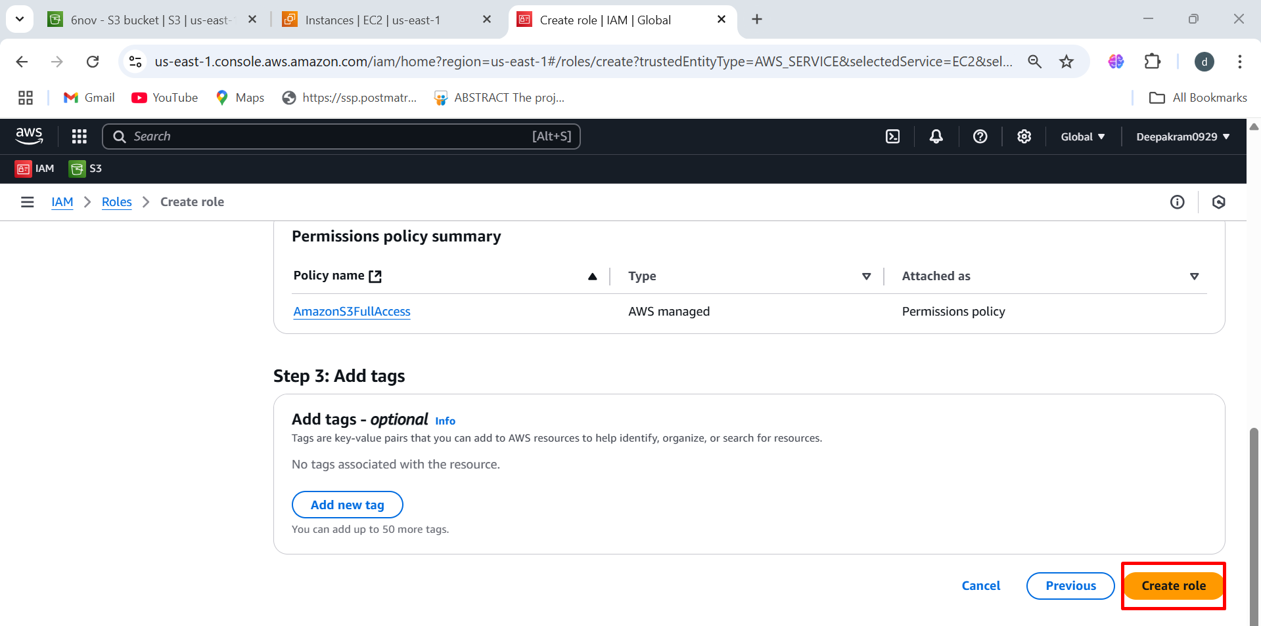

1. The role as been created successfully

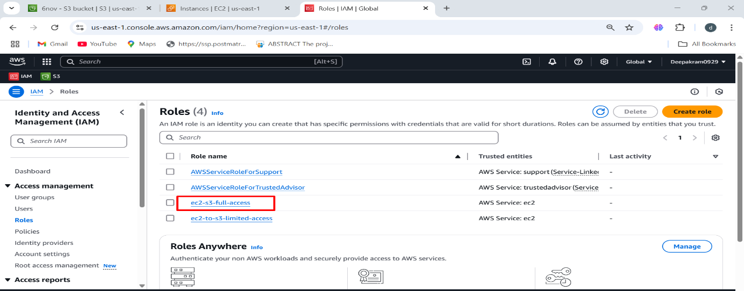

1. Select the instance 🡪 Click on actions 🡪 select security 🡪 modify IAM role

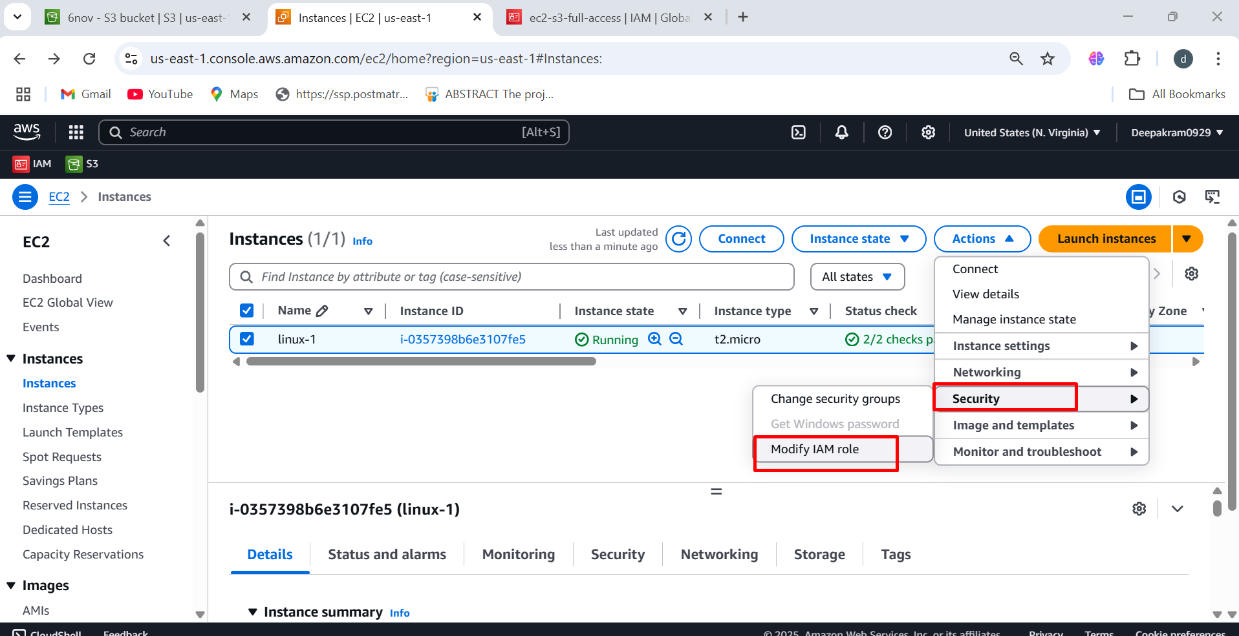

1. Select the IAM role 🡪 update IAM role

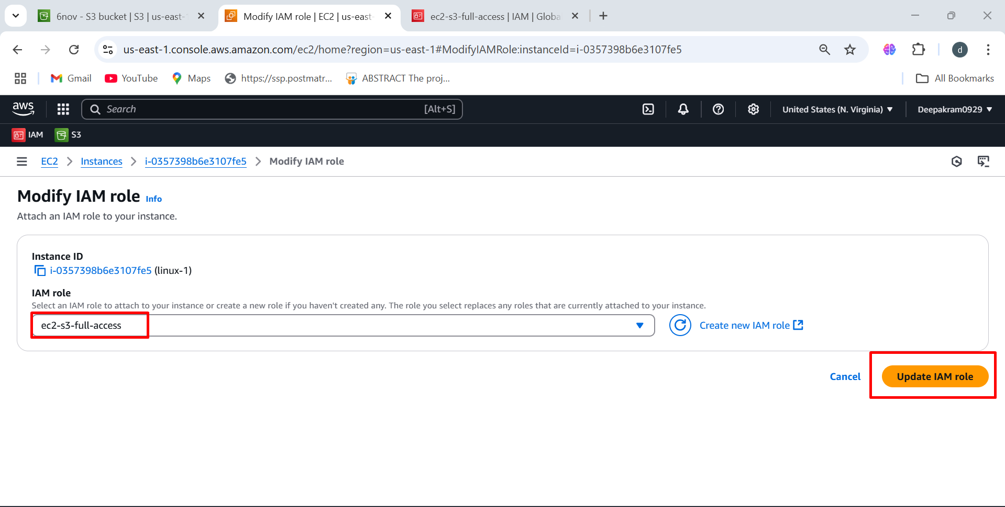

1. To upload all file from ec2 to s3 🡪 aws s3 sync . s3://7nov

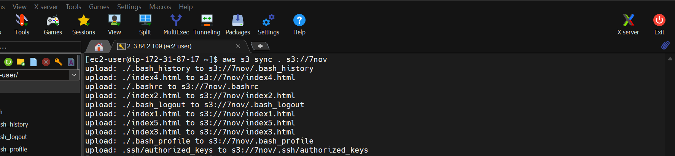

1. To download files from s3 to ec2 🡪 aws s3 cp s3://6nov/image1.jpg . (to present directory) dir1

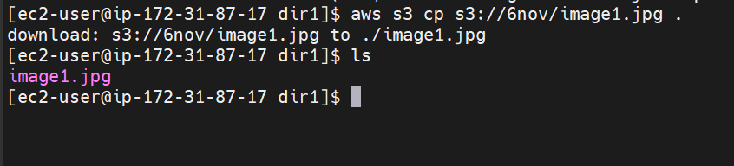

1. To upload all file from ec2 to s3 🡪 aws s3 sync . s3://7nov

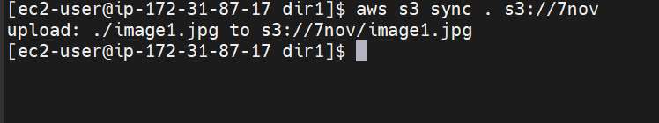

1. File as been uploaded to bucket

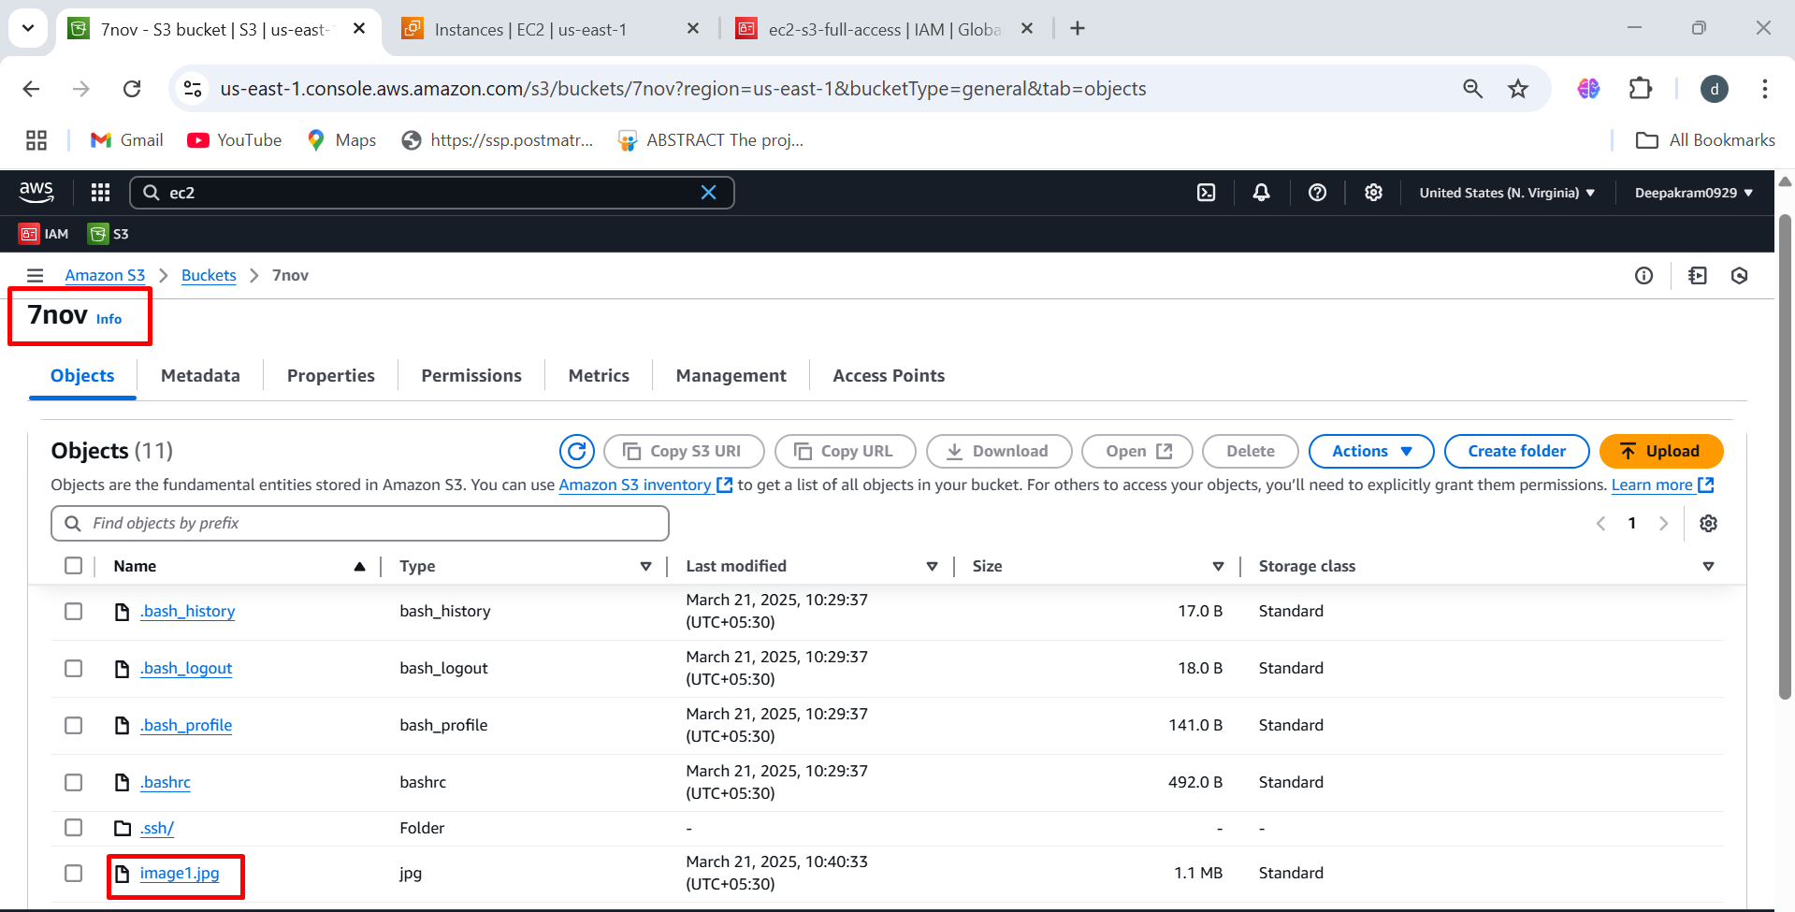

1. To delete specific file 🡪 aws s3 rm s3://7nov/image.jpg

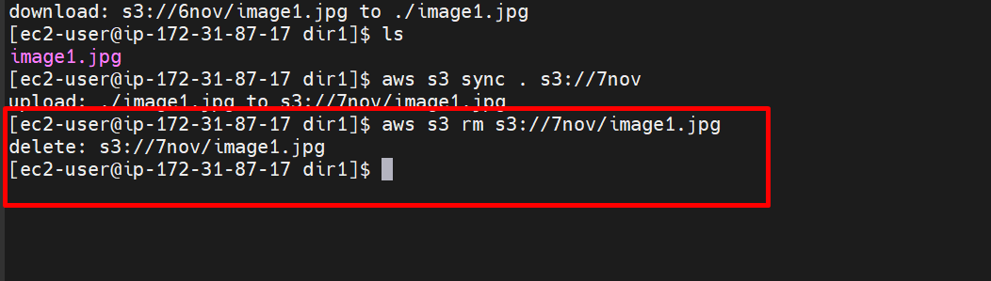

1. File as been removed from 7nov bucket

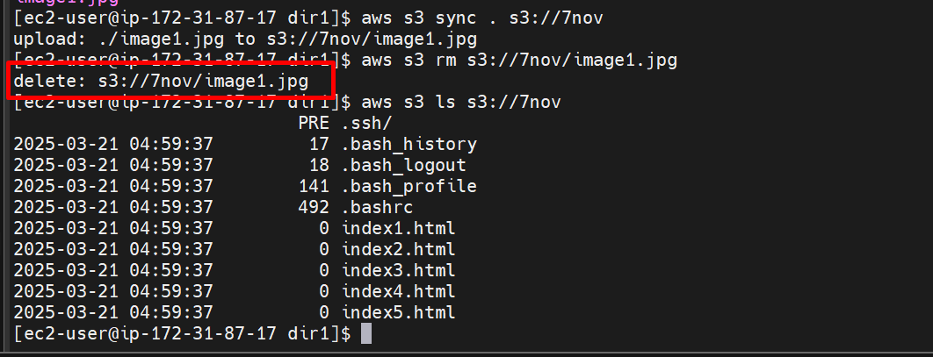

1. To delete multiple files 🡪 aws s3 rm s3://<bucket-name> --recursive

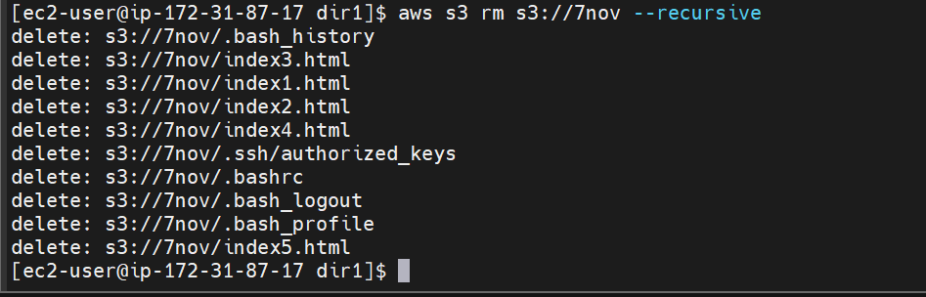

1. Complete files as been deleted present in the bucket

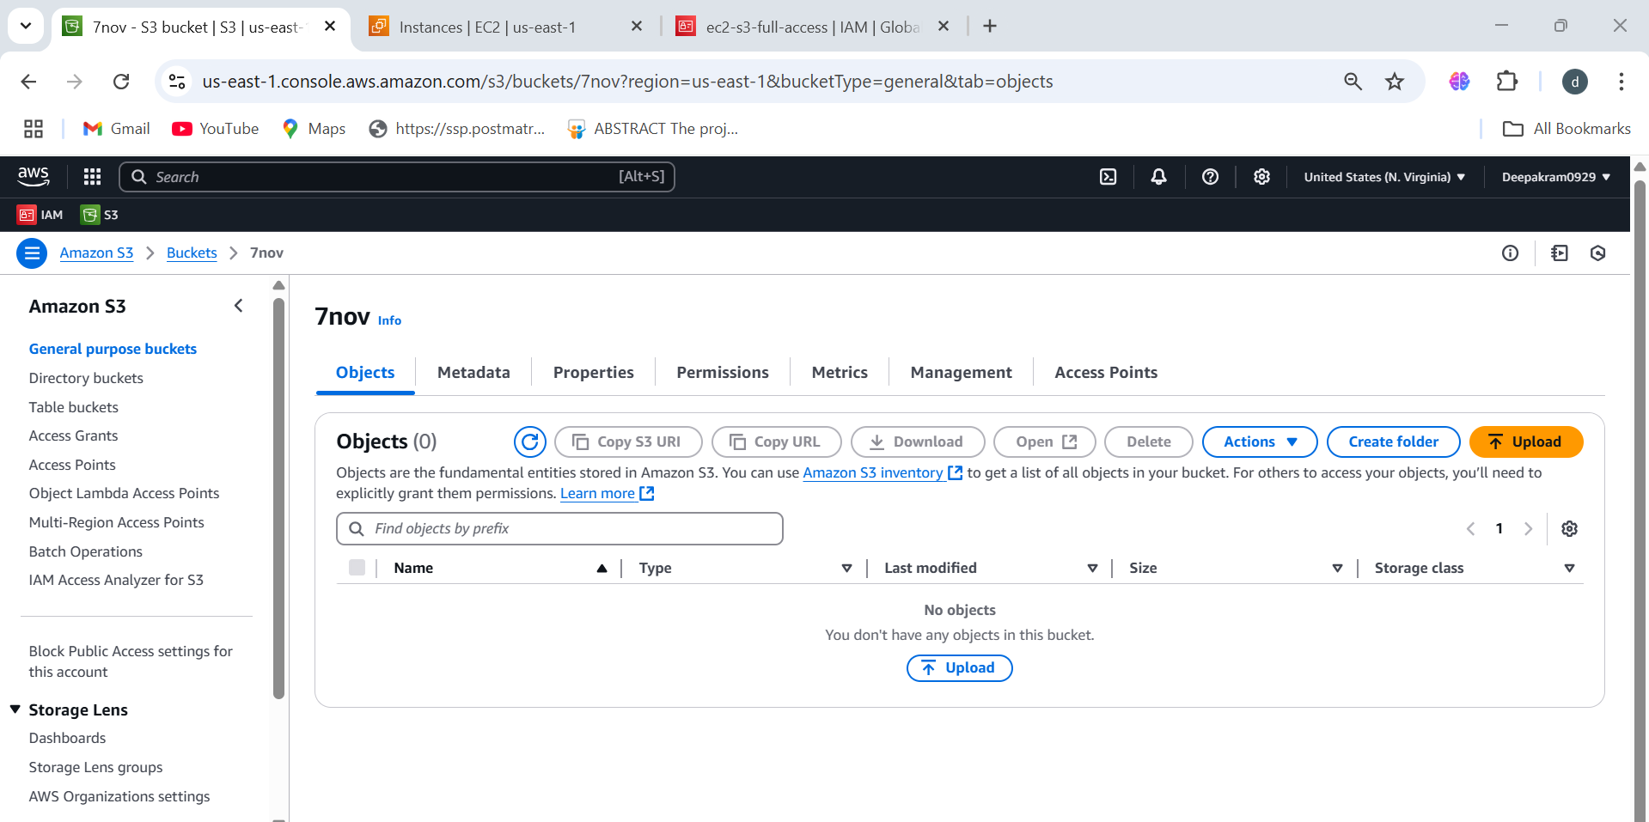

1. To upload all file from ec2 to s3 🡪 aws s3 sync . s3://7nov (. Dot is from present directory)

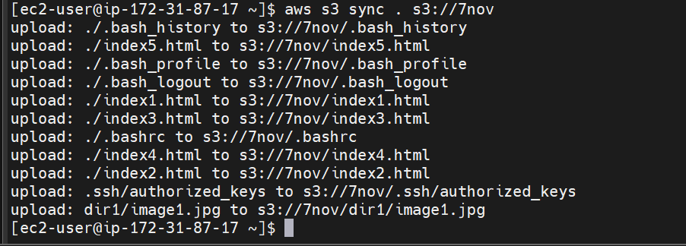

1. To upload specific files from ec2 to s3 🡪 aws s3 sync . s3://8nov --exclude "*" --include "*.html"

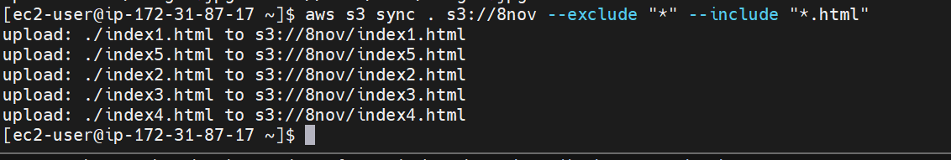

1. All html files are uploaded

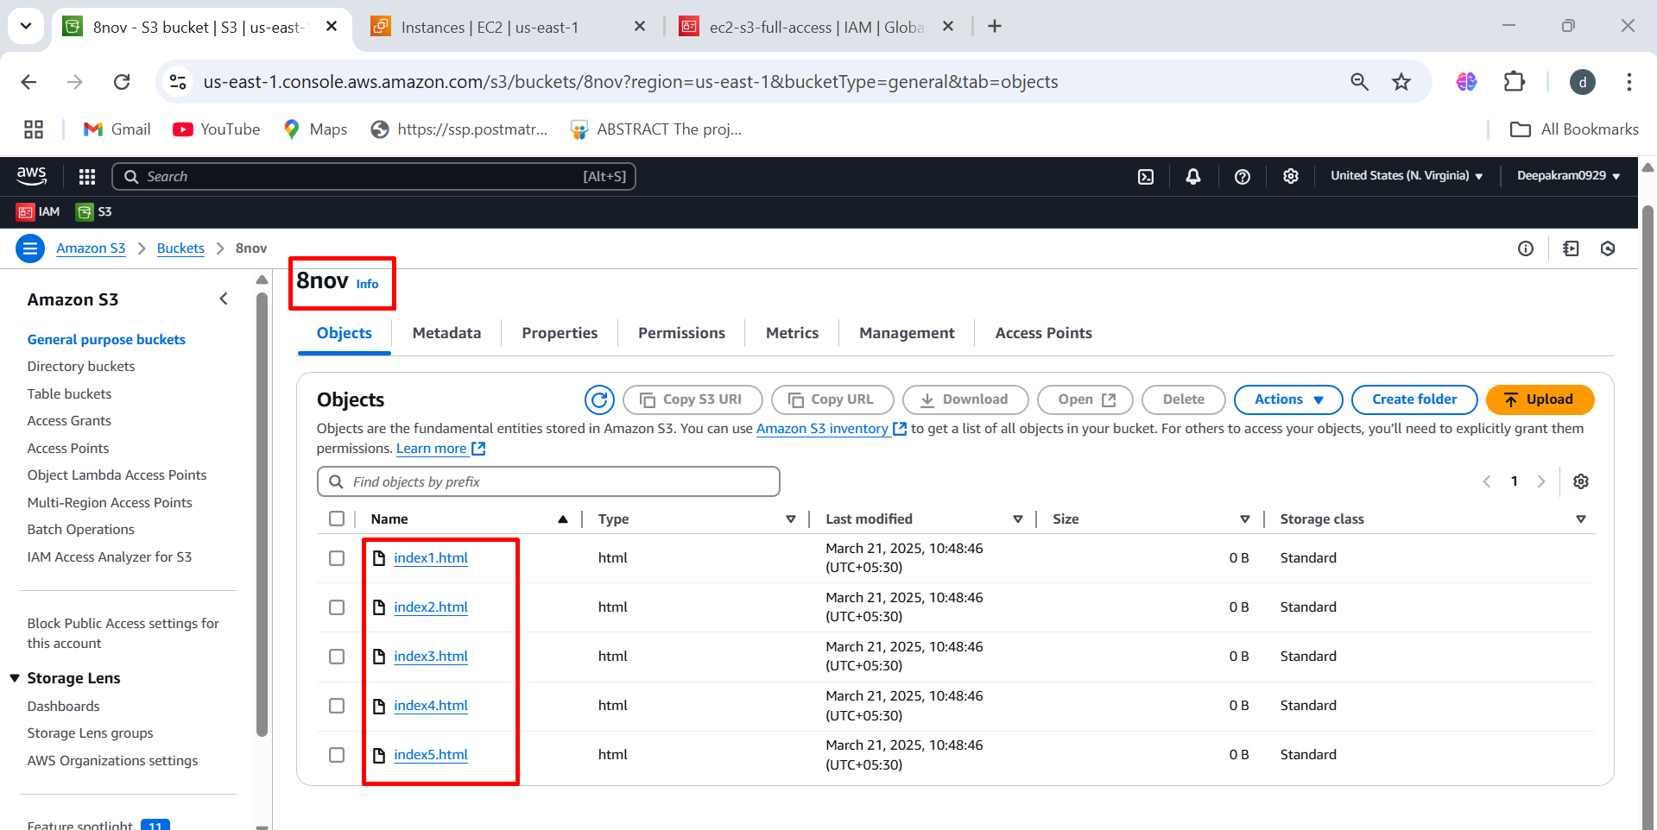

1. To upload specific files from s3 to ec2 🡪 aws s3 sync s3://6nov . --exclude "*" --include "*.jpeg"

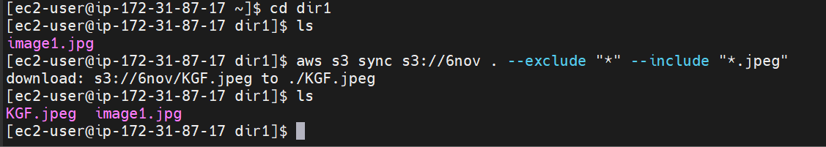

1. To copy multiple files from bucket to bucket 🡪 aws s3 sync s3://6nov s3://8nov

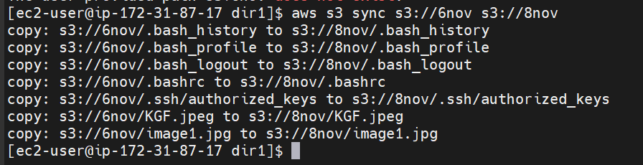

1. To copy single file from bucket to bucket🡪 aws s3 cp s3://6nov/KGF.jpeg s3://7nov

